**Supplementary Figure S1. A schema of study design**

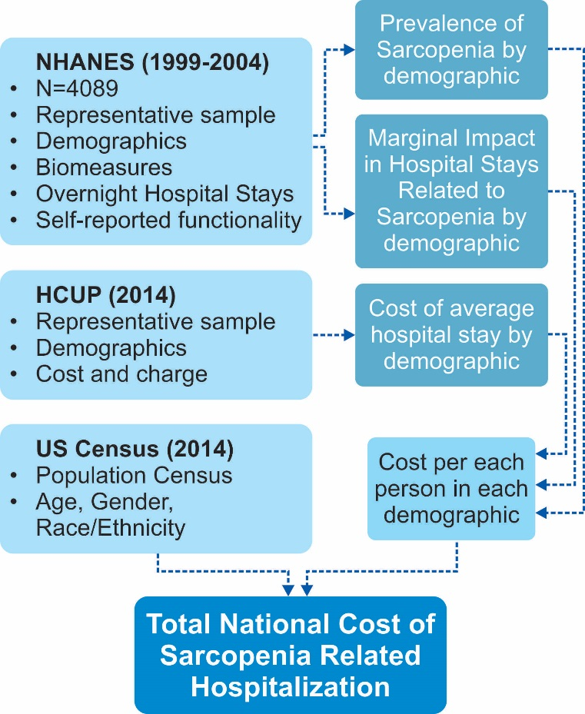

NHANES, National Health and Nutrition Examination Survey; HCUP, Healthcare Cost and Utilization Project; N, number of individuals