**ONLINE SUPPLEMENTAL CONTENT**

The Effect of Frailty on Independent Living After Surgery: A Population-based Retrospective Cohort Study

Garland, Mutter, Ekuma and Papadimitropolous

CONTENTS:

|  |  |
| --- | --- |
| ***Contents*** | ***Page*** |
| eTable 1: Surgical procedures includes, with procedure codes | 2-3 |
| Appendix 1: Principal Components Analysis for Model Overfitting | 4 |
| eTable 2: Principal components extracted from the six covariates | 4 |
| eTable 3: Factor loadings of orthogonally rotated principal components with eigenvalues exceeding 1.0 | 4 |
| eFigure 1: Statistically significant nonlinear relationships between Frailty Score and study outcomes. | 5 |
| Supplemental References | 6 |

**eTable 1.** 16 surgical procedures included, with Operative Stress Score (OSS) Categories, and Canadian Classification of Health Intervention (CCI) Codes

|  |  |  |  |  |
| --- | --- | --- | --- | --- |
| **OSS Score** | **Procedure** | **CCI Codes** | | |
| 2 | Knee arthoscopy | 1.VG.35.DA*  1.VG.52.DA*  1.VG.55.DA*  1.VG.58.DA*  1.VG.72.DA*  1.VG.73.DA*  1.VG.74.DA*  1.VG.80.DA*  1.VG.87.DA*  1.VG.80.FY*  1.VG.80.GZ*  1.VG.87.GB*  1.VK.80.DA*  1.VK.87.DA*  1.VK.89.DA*  1.VL.78.DA*  1.VL.78.FY*  1.VL.78.GB*  1.VL.80.DA*  1.VL.80.FY*  1.VL.80.GB*  1.VL.87.DA*  1.VL.87.FY* | 1.VL.87.GB*  1.VM.78.DA*  1.VM.78.FY*  1.VM.78.GB*  1.VM.80.DA*  1.VM.80.FY*  1.VM.80.GB*  1.VM.87.DA*  1.VM.87.FY*  1.VM.87.GB*  1.VN.78.DA*  1.VN.78.FY*  1.VN.78.GB*  1.VN.80.DA*  1.VN.80.FY*  1.VN.80.GB*  1.VN.87.DA*  1.VN.87.FY*  1.VN.87.GB*  1.VP.72.DA*  1.VP.80.DA*  1.VP.87.DA*  2.VG.70.DA*  2.VG.71.DA*  2.VK.71.DA*  2.VN.71.DA*  2.VP.71.DA* | |
| 2 | Open treatment with internal fixation of tibial fracture, with or without fibular fracture | 1.VQ.73.LA*  1.VQ.74.LA*  1.VQ.82* | | |
| 2 | Salpingoopherectomy | 1.RD.89* | | |
| 2 | Open large vessel endarterectomy/thrombectomy (excluding carotid) | 1.JJ.57*  1.JK.57*  1.JL.57*  1.JM.57*  1.KG.57* | | |
|  |  |  | | |
| 3 | Hysterectomy | 1.RM.89*  1.RM.91* | | |
| 3 | Hip arthroplasty | 1.VA.53.LA*  1.VA.80.LA* | | |
| 3 | Cholecystectomy | 1.OD.89* | | |
| 3 | Open large vessel artery bypass | 1.KG.76*  1.JM.76.MI*  1.JE.76.MV* | | |
|  |  |  | | |
| 4 | Gastrectomy | 1.NF.87 | | |
| 4 | Pulmonary Lobectomy | 1.GR.87*  1.GR.89*  1.GT.87.NA*  1.GT.87.QB* | | |
| 4 | Proctectomy | 1.NQ.87*  1.NQ.89* | | |
| 4 | Colectomy | 1.NM.87.LA*  1.NM.87.RN*  1.NM.87.RD*  1.NM.87.RE*  1.NM.89.RN*  1.NM.89.TF* | | |
|  |  |  | | |
| 5 | AAA repair | 1.KA.80.LA* | | |
| 5 | Esophagectomy | 1.NA.87.QG*  1.NA.87.QH*  1.NA.87.LD*  1.NA.87.LE*  1.NA.87.LQ*  1.NA.87.LP*  1.NA.87.QC*  1.NA.87.QD*  1.NA.87.QB* | | 1.NA.88.LB*  1.NA.88.QF*  1.NA.89.LB*  1.NA.89 QF*  1.NA.90*  1.NA.91.LB*  1.NA.91.QF*  1.NA.92* |
| 5 | Pancreatectomy | 1.OJ.87.LA*  1.OJ.87.VC*  1.OJ.87.VK*  1.OK.87* | | |
| 5 | Pneumonectomy | 1.GT.89*  1.GT.91* | | |

APPENDIX 1. Principal Components Analysis for Model Overfitting

In principal components analysis (PCA), a group of M independent variables are replaced by M principal component variables, each of which is a linear combination of the original variables.(1, 2) While the total information content of all components is the same as all the original variables, the calculation is such that as much as possible of the entire information content is contained in the 1st principal component. Of the remaining M-1 components, as much as possible of the remaining information content is contained in the 2nd principal component, and so on. Measures of the information content of the components are the eigenvalues and proportion of total variance (eTable 2). A common recommendation is to retain at least the principal components with eigenvalues exceeding 1.0.(1)

A common use of PCA is to reduce the number of covariates in an analysis while retaining as much of the information content as possible. Such *data reduction* is often necessitated by the problem of regression model overfitting. Overfitting refers to the problem where a model with too many independent variables for the number of available subjects (or outcomes) fits very well to the given sample, but fits very poorly to any other random sample taken from the same population.(3, 4)A general rule of thumb to avoid model overfitting is to ensure at least 10 events per independent variable in the model.(2, 5)

For some of our outcomes, including the primary outcome, there were relatively few events compared to the number of covariates we wished to include analyses of the association of frailty with outcomes. Accordingly, we converted our six covariates (age, sex, OSS, year of surgery, anesthetic technique [general vs. any other], and area-level socioeconomic status assessed by the SEFI-2 score.(6)) to principal components, retaining for each analysis the maximum number of components that still allowed for at least 10 events per independent variable in the model. The eigenvalues and component loadings are shown in eTable 2 and eTable 3. In all cases we retained at least the components with eigenvalues exceeding 1.0.

Of note, as these covariates included binary, ordinal and metric variable types, prior to performing principal components analysis we optimally transformed them using the PRINQUAL procedure in SAS.(7)

eTable 2. Principal components extracted from the six covariates.

|  |  |  |
| --- | --- | --- |
| *Component* | *Eigenvalue* | *Fraction of Total Variance Explained* |
| 1 | 1.63 | 0.2723 |
| 2 | 1.15 | 0.1908 |
| 3 | 1.04 | 0.1732 |
| 4 | 0.90 | 0.1506 |
| 5 | 0.87 | 0.1447 |
| 6 | 0.41 | 0.0684 |
| Sum: | 6.00 | 1.0000 |

eTable 3. Factor loadings of orthogonally rotated principal components with eigenvalues exceeding 1.0

|  |  |  |  |
| --- | --- | --- | --- |
| *Transformed variable* | *Component 1* | *Component 2* | *Component 3* |
| Age | -0.1094 | 0.74601 | -0.15442 |
| Socioeconomic Factor-2 score | 0.19805 | 0.29237 | 0.66605 |
| Female sex | -0.24696 | -0.19768 | 0.73944 |
| General anesthesia vs. other types | 0.86223 | -0.07693 | 0.09622 |
| Year of index procedure | -0.08669 | -0.65342 | -0.19337 |
| Operative Stress Score | 0.86854 | 0.06794 | -0.14548 |

eFigure 1. Statistically significant nonlinear relationships between Frailty Score and study outcomes.

A. Post-hospital outpatient physician visits (prorated)

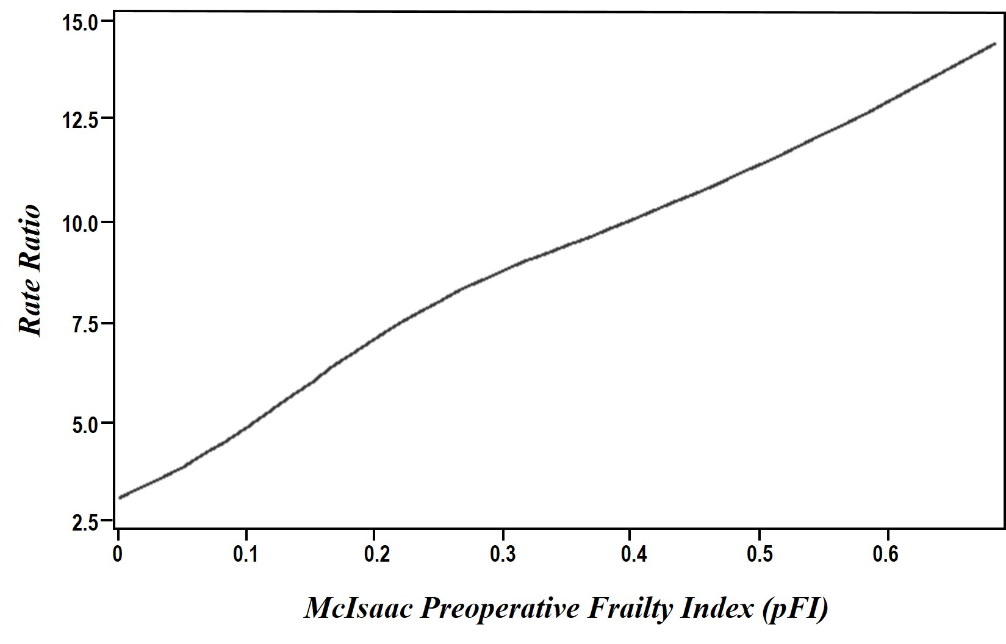

B. Post-hospital hospital-days (prorated)

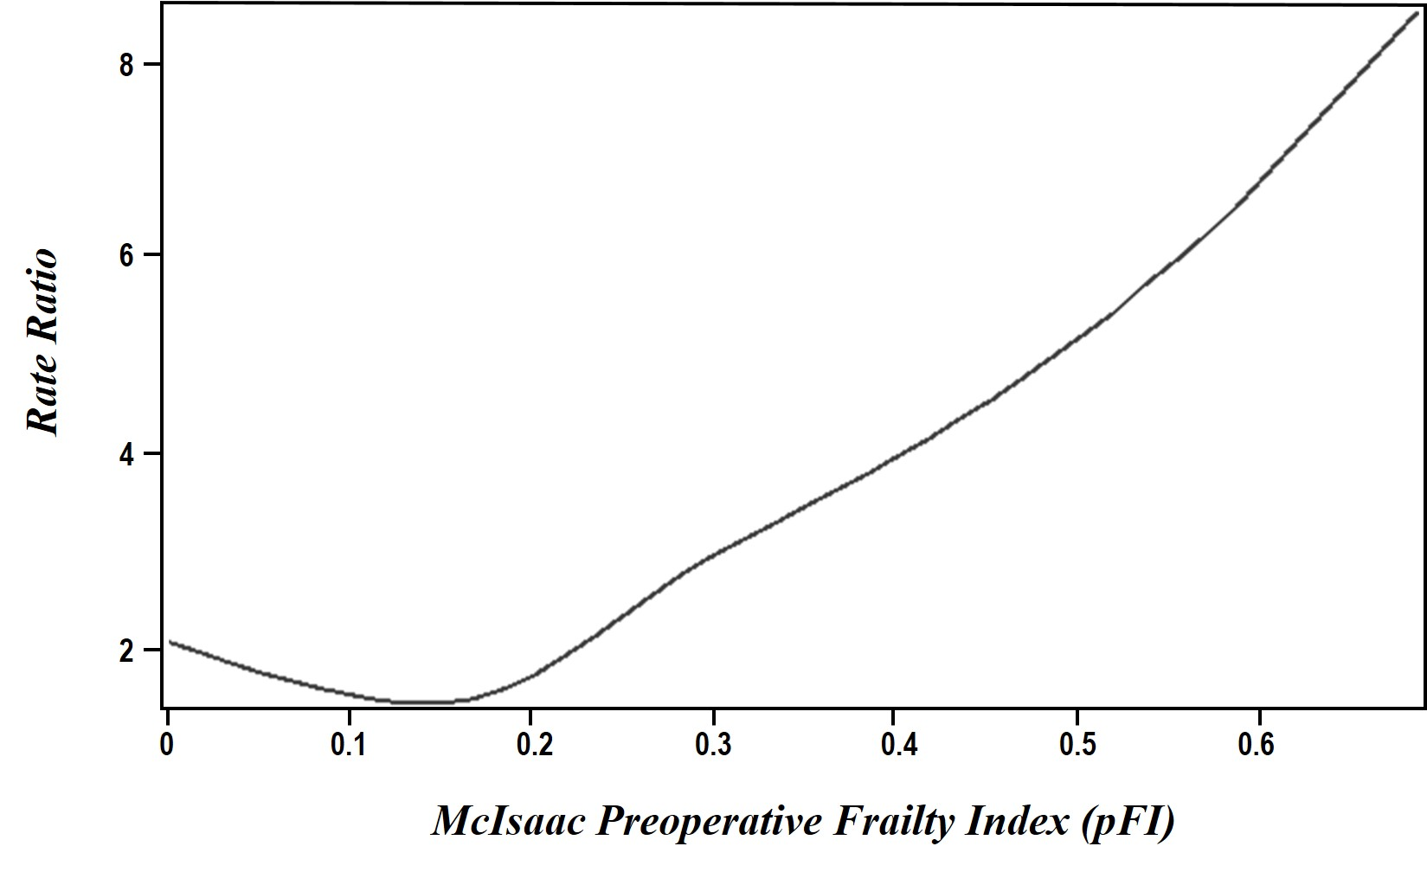

**SUPPLEMENTAL REFERENCES:**

1. Dunteman GH. Principal Components Analysis. *Quantitative Applications in the Social Sciences* 1989; 69

2. Harrell Jr. FE. Regression Modeling Strategies: Data Reduction. New York: Springer; 2001. p. 66-74.

3. Harrell Jr. FE. Regression Modeling Strategies: Overfitting. New York: Springer; 2001. p. 60-61.

4. The Danger of Overfitting Regression Models. 2022 [cited 2022 February 15]. Available from: https://blog.minitab.com/blog/adventures-in-statistics-2/the-danger-of-overfitting-regression-models.

5. Babyak MA. What You See May Not Be What You Get: A Brief, Nontechnical Introduction to Overfitting in Regression-Type Models. *Psychosomatic Medicine* 2004; 66: 411-421; DOI:10.1097/01.psy.0000127692.23278.a9

6. Chateau D, Metge C, Prior H, Soodeen R. Learning from the census: the Socio-economic Factor Index (SEFI) and health outcomes in Manitoba. *Canadian Journal of Public Health* 2012; 103: S23-S27; DOI:10.1007/BF03403825

7. The PRINQUAL Procedure. SAS/STAT® 141 User’s Guide: SAS Institute; 2015.