**Supplementary table 1.** Read codes used to identify hip osteoarthritis (A) and knee osteoarthritis (B)

(A) Hip osteoarthritis

|  |  |
| --- | --- |
| Read code | Read term |
| N051500 | Localised, primary osteoarthritis of the pelvic region/thigh |
| N051900 | Primary coxarthrosis, bilateral |
| N053500 | Localised osteoarthritis, unspecified, pelvic region/thigh |
| N053512 | Hip osteoarthritis NOS |
| N05z500 | Osteoarthritis NOS, pelvic region/thigh |
| N05z511 | Hip osteoarthritis NOS |
| N05zJ00 | Osteoarthritis NOS, of hip |
| N06z500 | Arthropathy NOS, of the pelvic region and thigh |
| Nyu2100 | [X]Other primary coxarthrosis |

(B) Knee osteoarthritis

|  |  |
| --- | --- |
| Read code | Read term |
| N051B00 | Primary gonarthrosis, bilateral |
| N053611 | Patellofemoral osteoarthritis |
| N05z611 | Knee osteoarthritis NOS |
| N05zL00 | Osteoarthritis NOS, of knee |
| N06z611 | Knee osteoarthritis NOS |

**Supplementary Table 2**. Deficits included in the electronic Frailty Index (eFI)

|  |
| --- |
| Deficit |
| Activity limitation |
| Anaemia & haematinic deficiency |
| Arthritis |
| Atrial fibrillation |
| Cerebrovascular disease |
| Chronic kidney disease |
| Diabetes |
| Dizziness |
| Dyspnoea |
| Falls |
| Foot problems |
| Fragility fracture |
| Hearing impairment |
| Heart failure |
| Heart valve disease |
| Housebound |
| Hypertension |
| Hypotension / syncope |
| Ischaemic heart disease |
| Memory & cognitive problems |
| Mobility and transfer problems |
| Osteoporosis |
| Parkinsonism & tremor |
| Peptic ulcer |
| Peripheral vascular disease |
| Polypharmacy |
| Requirement for care |
| Respiratory disease |
| Skin ulcer |
| Sleep disturbance |
| Social vulnerability |
| Thyroid disease |
| Urinary incontinence |
| Urinary system disease |
| Visual impairment |
| Weight loss & anorexia |

**Supplementary Table 3.** Proportion of participants who received a total hip and knee arthroplasty, stratified by frailty status

|  |  |  |
| --- | --- | --- |
| Frailty category | Hip osteoarthritis cohort | Knee osteoarthritis cohort |
| Received THA, n (row %) | Received TKA, n (row %) |
| Fit | 15698 (40.1) | 15649 (19.8) |
| Mild frailty | 13506 (31.5) | 15267 (16.9) |
| Moderate frailty | 4060 (23.2) | 4402 (12.3) |
| Severe frailty | 835 (15.4) | 749 (6.9) |

THA: Total hip arthroplasty; TKA: Total knee arthroplasty

**Supplementary Table 4.** Proportion of participants who received a total hip and knee arthroplasty, stratified by quintile of index of multiple deprivation

|  |  |  |
| --- | --- | --- |
| Quintile of index of multiple deprivation | Hip osteoarthritis cohort | Knee osteoarthritis cohort |
| Received THA, n (row %) | Received TKA, n (row %) |
| 1 (least deprived) | 9117 (33.8) | 8990 (17.6) |
| 2 | 8398 (33.9) | 8555 (17.5) |
| 3 | 7356 (33.8) | 7846 (17.4) |
| 4 | 5471 (31.0) | 6106 (15.8) |
| 5 (most deprived) | 3757 (27.4) | 4570 (14.0) |

**Supplementary Table 5.** Subhazard ratio for THA and TKA by frailty category among people who had BMI recorded

|  |  |  |  |
| --- | --- | --- | --- |
|  | Subhazard ratio (95% CI) | | |
| Frailty category | Model 1 | Model 2 | Model 3 |
|  | *THA* | | |
| Fit | Reference | | |
| Mild frailty | 0.79 (0.76, 0.82) | 0.80 (0.76, 0.83) | 0.79 (0.76, 0.83) |
| Moderate frailty | 0.58 (0.55, 0.61) | 0.59 (0.56, 0.63) | 0.59 (0.56, 0.62) |
| Severe frailty | 0.39 (0.35, 0.43) | 0.40 (0.37, 0.44) | 0.40 (0.36, 0.44) |
|  | *TKA* | | |
| Fit | Reference | | |
| Mild frailty | 0.95 (0.91, 0.99) | 0.96 (0.93, 1.00) | 0.94 (0.91, 0.98) |
| Moderate frailty | 0.75 (0.71, 0.79) | 0.77 (0.73, 0.81) | 0.74 (0.71, 0.78) |
| Severe frailty | 0.49 (0.45, 0.54) | 0.51 (0.47, 0.56) | 0.49 (0.45, 0.54) |

THA: Total hip arthroplasty; TKA: Total knee arthroplasty

Model 1: adjusted for year of OA diagnosis, age at OA diagnosis and sex

Model 2: adjusted for year of OA diagnosis, age at OA diagnosis, sex, and quintile of IMD

Model 3: adjusted for year of OA diagnosis, age at OA diagnosis, sex, quintile of IMD, and BMI

**Supplementary Table 6.** Subhazard ratio for THA and TKA by frailty category among people who had ethnicity recorded

|  |  |  |  |
| --- | --- | --- | --- |
|  | Subhazard ratio (95% CI) | | |
| Frailty category | Model 1 | Model 2 | Model 3 |
|  | *THA* | | |
| Fit | Reference | | |
| Mild frailty | 0.78 (0.76, 0.80) | 0.78 (0.77, 0.80) | 0.79 (0.77, 0.81) |
| Moderate frailty | 0.59 (0.56, 0.61) | 0.59 (0.57, 0.62) | 0.60 (0.58, 0.62) |
| Severe frailty | 0.41 (0.39, 0.44) | 0.42 (0.39, 0.46) | 0.43 (0.40, 0.46) |
|  | *TKA* | | |
| Fit | Reference | | |
| Mild frailty | 0.98 (0.95, 1.00) | 0.98 (0.96, 1.01) | 0.99 (0.97, 1.01) |
| Moderate frailty | 0.82 (0.79, 0.85) | 0.83 (0.80, 0.86) | 0.84 (0.81, 0.87) |
| Severe frailty | 0.55 (0.51, 0.59) | 0.57 (0.52, 0.61) | 0.57 (0.53, 0.62) |

Analysis was restricted to those who have ethnicity recorded: 101,001 people in the hip cohort (96% of the hip cohort) and 206,191 people in the knee cohort (95% of the knee cohort).

Model 1: adjusted for year of OA diagnosis, age at OA diagnosis and sex

Model 2: adjusted for year of OA diagnosis, age at OA diagnosis, sex, and quintile of IMD

Model 3: adjusted for year of OA diagnosis, age at OA diagnosis, sex, quintile of IMD, and ethnicity

**Supplementary Table 7.** Subhazard ratio for THA and TKA by quintile of index of multiple deprivation among people who had BMI recorded

|  |  |  |  |
| --- | --- | --- | --- |
|  | Subhazard ratio (95% CI) | | |
| Quintile of index of multiple deprivation | Model 1 | Model 2 | Model 3 |
|  | *THA* | | |
| 1 (least deprived) | Reference | | |
| 2 | 1.00 (0.95, 1.05) | 1.02 (0.97, 1.07) | 1.02 (0.97, 1.07) |
| 3 | 1.00 (0.95, 1.05) | 1.03 (0.98, 1.08) | 1.03 (0.98, 1.08) |
| 4 | 0.87 (0.82, 0.91) | 0.91 (0.86, 0.96) | 0.91 (0.86, 0.96) |
| 5 (most deprived) | 0.72 (0.68, 0.77) | 0.79 (0.74, 0.83) | 0.78 (0.74, 0.83) |
|  | *TKA* | | |
| 1 (least deprived) | Reference | | |
| 2 | 0.99 (0.94, 1.04) | 1.00 (0.95, 1.05) | 0.99 (0.95, 1.04) |
| 3 | 0.93 (0.89, 0.98) | 0.95 (0.90, 1.00) | 0.94 (0.89, 0.99) |
| 4 | 0.84 (0.80, 0.89) | 0.87 (0.82, 0.91) | 0.85 (0.81, 0.90) |
| 5 (most deprived) | 0.74 (0.70, 0.78) | 0.77 (0.73, 0.82) | 0.76 (0.72, 0.80) |

Analysis was restricted to those who have BMI recorded: 41,693 people in the hip cohort (40% of the hip cohort) and 87,872 people in the knee cohort (41% of the knee cohort)

Model 1: adjusted for year of OA diagnosis, age at OA diagnosis and sex

Model 2: adjusted for year of OA diagnosis, age at OA diagnosis, sex, and eFI category at time of OA diagnosis

Model 3: adjusted for year of OA diagnosis, age at OA diagnosis, sex, eFI category at time of OA diagnosis, and BMI

**Supplementary Table 8.** Subhazard ratio for THA and TKA by quintile of index of multiple deprivation among people who had ethnicity recorded

|  |  |  |  |
| --- | --- | --- | --- |
|  | Subhazard ratio (95% CI) | | |
| Quintile of index of multiple deprivation | Model 1 | Model 2 | Model 3 |
|  | *THA* | | |
| 1 (least deprived) | Reference | | |
| 2 | 1.01 (0.98, 1.04) | 1.02 (0.99, 1.05) | 1.02 (0.99, 1.05) |
| 3 | 1.00 (0.97, 1.03) | 1.02 (0.99, 1.05) | 1.02 (0.99, 1.06) |
| 4 | 0.91 (0.88, 0.95) | 0.95 (0.92, 0.98) | 0.96 (0.93, 0.99) |
| 5 (most deprived) | 0.79 (0.76, 0.82) | 0.84 (0.81, 0.88) | 0.86 (0.82, 0.89) |
|  | *TKA* | | |
| 1 (least deprived) | Reference | | |
| 2 | 1.00 (0.97, 1.03) | 1.00 (0.98, 1.04) | 1.01 (0.98, 1.04) |
| 3 | 0.99 (0.96, 1.02) | 1.00 (0.97, 1.03) | 1.01 (0.98, 1.04) |
| 4 | 0.90 (0.87, 0.93) | 0.91 (0.89, 0.95) | 0.92 (0.89, 0.95) |
| 5 (most deprived) | 0.80 (0.77, 0.83) | 0.82 (0.79, 0.85) | 0.83 (0.80, 0.86) |

Analysis was restricted to those who have ethnicity recorded: 101,001 people in the hip cohort (96% of the hip cohort) and 206,191 people in the knee cohort (95% of the knee cohort)

Model 1: adjusted for year of OA diagnosis, age at OA diagnosis and sex

Model 2: adjusted for year of OA diagnosis, age at OA diagnosis, sex, and eFI category at time of OA diagnosis

Model 3: adjusted for year of OA diagnosis, age at OA diagnosis, sex, eFI category at time of OA diagnosis, and ethnicity category

**Supplementary text**

**Association between the electronic frailty index and total hip or knee arthroplasty**

In our primary analysis, we categorised the eFI based on previously published thresholds (19). As a supplementary analysis, we also analysed the eFI as a continuous variable. We determined the association between the eFI (continuous variable) at the date of OA diagnosis and likelihood of receiving THA or TKA using a multivariable Cox regression model. To allow a nonlinear relationship between the eFI and the likelihood of receiving a THA or TKA, we included fractional polynomial terms for the eFI (37).

The best fitting model (defined as the model with the lowest deviance, which is twice the negative log likelihood), was selected after comparing all possible combinations of the following powers of the eFI: -2, -1, -0.5, 0.5, 1, 2, and 3, as well as the natural logarithm of eFI.

To aid comparison with the primary analysis (where the eFI was modelled as a categorial variable with the ‘fit’ category as the reference group), the eFI was centred at 0.08, which was the median value among individuals classified as fit, in both the hip and knee cohorts.

As in our primary analysis, individuals contributed person-time to the analysis from the first recorded date of hip or knee OA diagnosis (incident OA) until the date of receiving THA or TKA, date of death, the date the individual’s primary care practice stopped contributing data to the CPRD, or 31 March 2019 (end of study period), whichever came first.

We adjusted the Cox regression models for year of OA diagnosis, age at OA diagnosis, and sex (based on primary care records).

In the hip cohort, the best fitting Cox regression model included a linear term for the eFI and a fractional polynomial term for eFI0.5. In the knee cohort, the Cox regression model included a fractional polynomial term for eFI0.5 and eFI2.

Plots of the fitted values from the best fitting models in the hip and knee cohorts are shown in Supplementary Figure 2. Hazard ratios are relative to individuals with an eFI of 0.08. To aid comparison with the primary analysis, the thresholds for mild, moderate, and severe frailty are indicated by vertical dashed lines.

**Supplementary figure 1.** Participant flow diagram





**Supplementary figure 2.** Fitted values from a Cox model with fractional polynomial terms for the electronic frailty index

A. Hazard ratio for total hip arthroplasty

Severe

frailty

Moderate

frailty

Mild

frailty

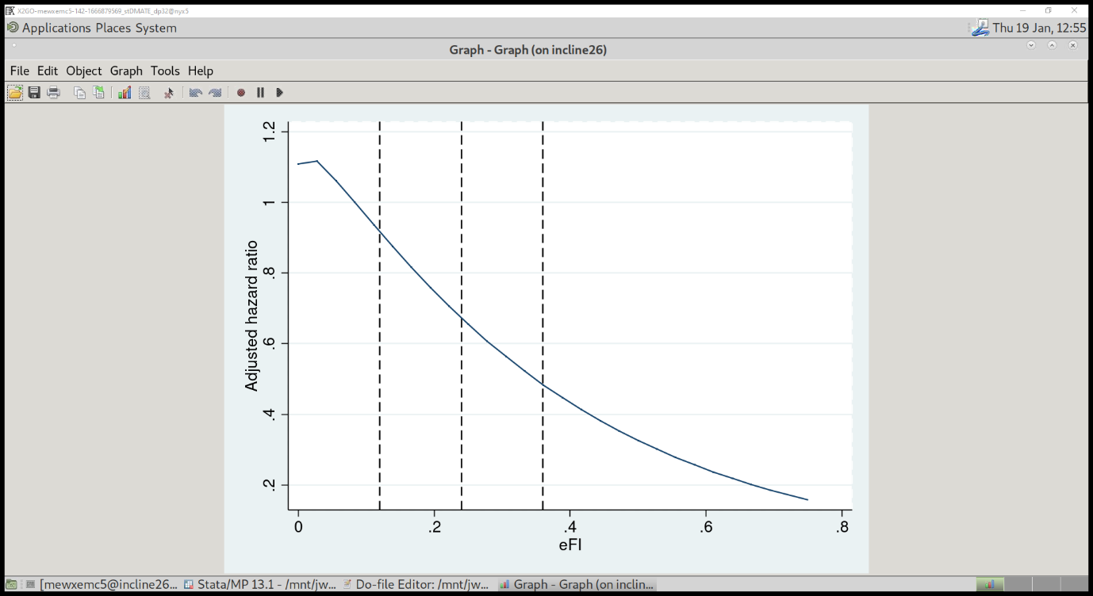

Hazard ratios are relative to individuals with an eFI of 0.08

A linear term for the eFI and a fractional polynomial term for eFI0.5 were included in the Cox model.

B. Hazard ratio for total knee arthroplasty

Severe

frailty

Moderate

frailty

Mild

frailty

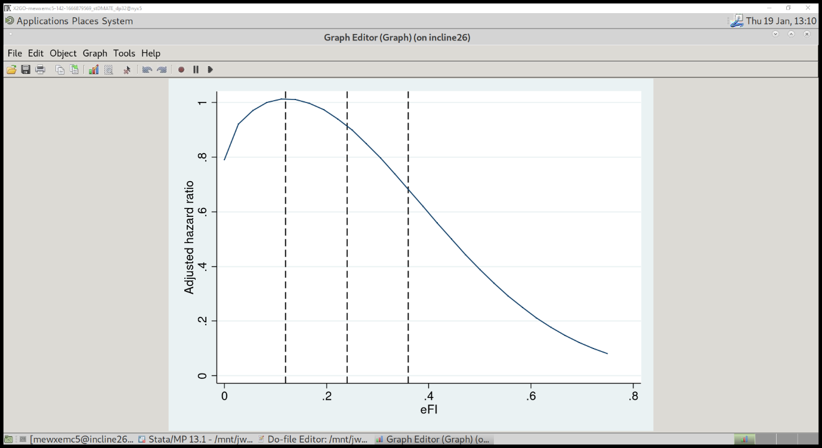

Hazard ratios are relative to individuals with an eFI of 0.08

A fractional polynomial term for eFI0.5 and eFI2 were included in the Cox model.