APPENDIX 1 - Search strategy for Ovid Medline

1. Geriatrics/exp
2. Geriatric*
3. Aged/exp
4. Age*
5. Elderly
6. Older adult*
7. Sarcopenia/exp
8. Sarcopeni*
9. 1,2,3,4,5,6,7,8 OR
10. (laparotom* adj5 emergenc*)
11. (laparotom* adj5 urgent*)
12. (emergen* adj5 (surg* adj5 abdom*)
13. (urgent* adj5 (surg* adj5 abdom*))
14. Laparotomy/exp
15. Emergen*
16. Urgent*
17. 15 OR 16
18. 17 AND 14
19. 10,11,12,13,18 OR
20. Risk factors/exp
21. Risk assessment/exp
22. Prognos*
23. Sensitivity
24. Specificity
25. ROC curve*
26. Predictive value*
27. Predict*
28. Decision support technique*
29. Exp* decision*
30. Decision aid*
31. Decision analysis
32. Decision model*
33. Decision support
34. Causality/exp
35. Causal*
36. 20,21,22,23,24,25,26,27,28,29,30,31,32,33,34,35 OR
37. 9 AND 19 AND 36

APPENDIX 2 - Quality assessment of included studies using the NOS

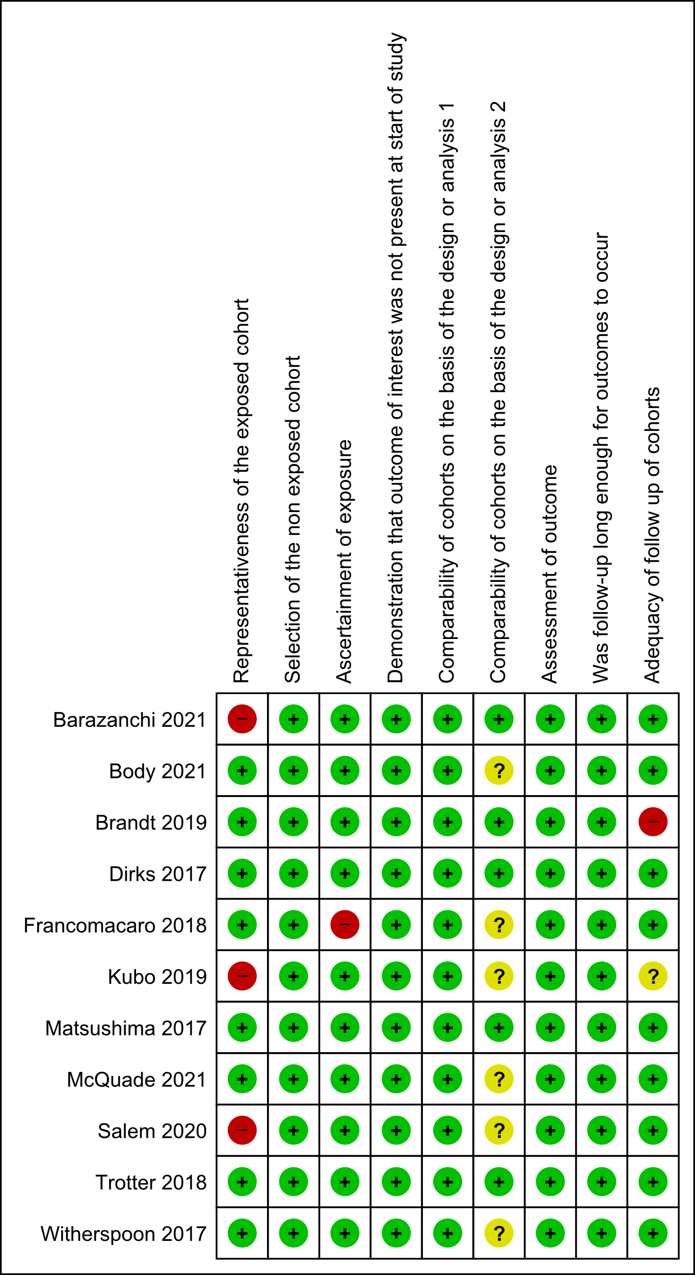

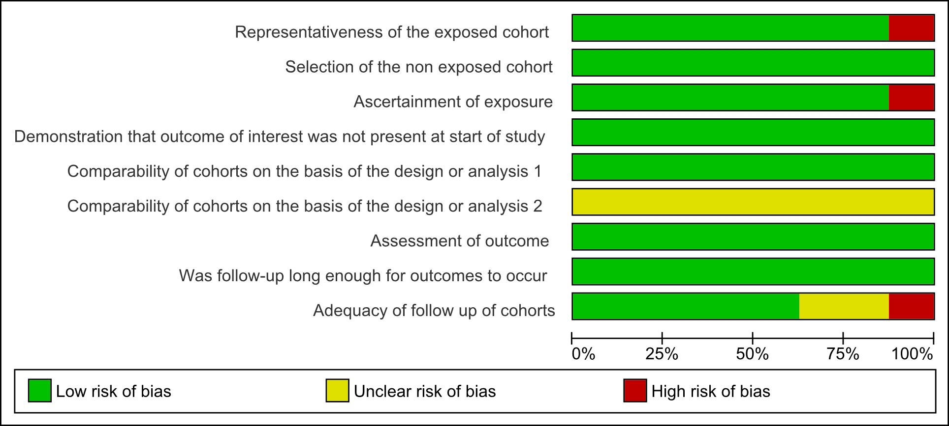

|  |  |  |  |  |
| --- | --- | --- | --- | --- |
|  | Selection (0-4)+ | Comparability (0-2)& | Exposure/Outcome (0-3)& | Conclusion |
| Barazanchi 2021 | Good | Good | Good | Good |
| Body 2021 | Good | ***Fair*** | Good | ***Fair*** |
| Brandt 2019 | Good | Good | Good | Good |
| Dirks 2017 | Good | Good | Good | Good |
| Francomacaro 2018 | Good | ***Fair*** | Good | ***Fair*** |
| Kubo 2019 | Good | ***Fair*** | Good | ***Fair*** |
| Matsushima 2017 | Good | Good | Good | Good |
| McQuade 2021 | Good | ***Fair*** | Good | ***Fair*** |
| Salem 2020 | Good | ***Fair*** | Good | ***Fair*** |
| Trotter 2018 | Good | Good | Good | Good |
| Witherspoon 2017 | Good | ***Fair*** | Good | ***Fair*** |

The risk of bias table was summarised into its respective domains. Judgement of quality in each domain utilised the following numerical values {Donnelly, 2017 #2652}: +Domain scored: 0-1 (Poor); 2 (Fair); 3+ (Good), &Domain scored: 0 (Poor); 1 (Fair); 2 (Good)