**Supplementary Figure 1. Association between calf circumference and mortality at T3, T6, T12 (smooth plots and 95% CI)**

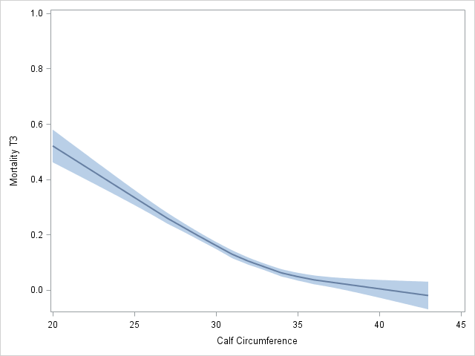

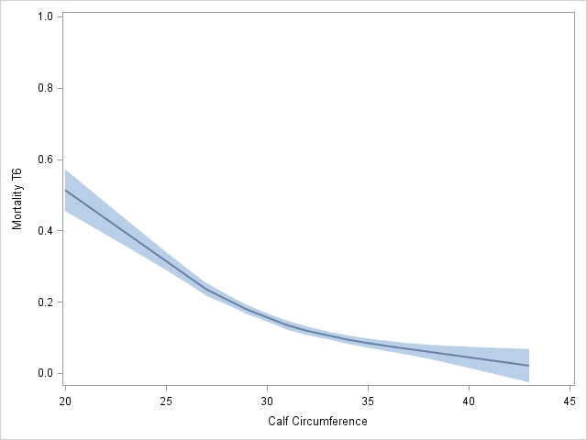

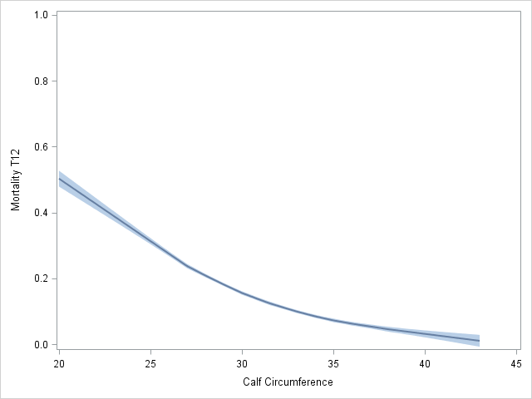

*Notes*: T3: 3 months after discharge; T6: 6 months after discharge; T12: 12 months after discharge. Calf circumference is measured in centimeters (cm).