Supplementary Figure 1. Generalized estimating equation post-hoc predictive margins prediction for probability of frailty (0,1) over time by food insecurity (FI) and vision impairment (VI) status
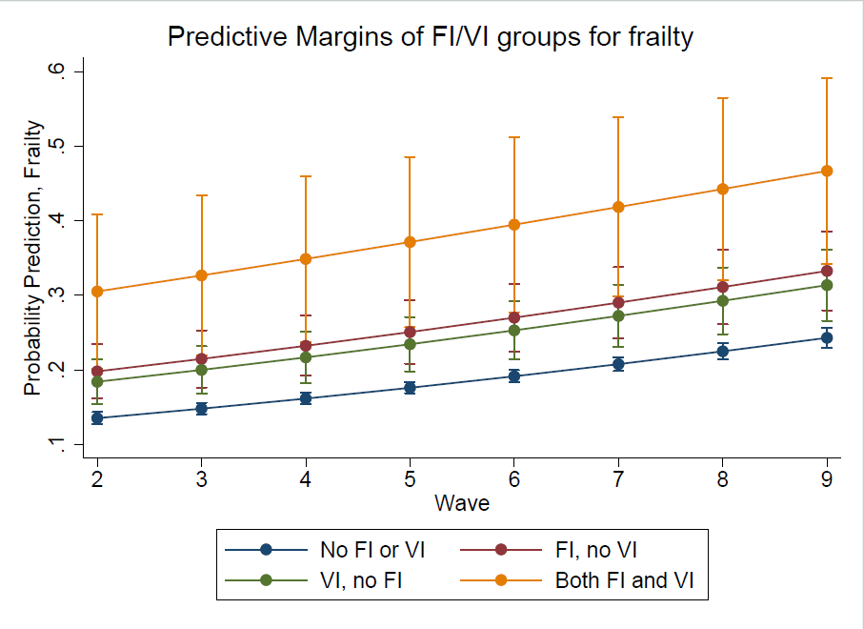

Supplementary Figure 2. Generalized estimating equation post-hoc predictive margins prediction for probability of risk of multiple falls in last year (0,1) over time by food insecurity (FI) and vision impairment (VI) status
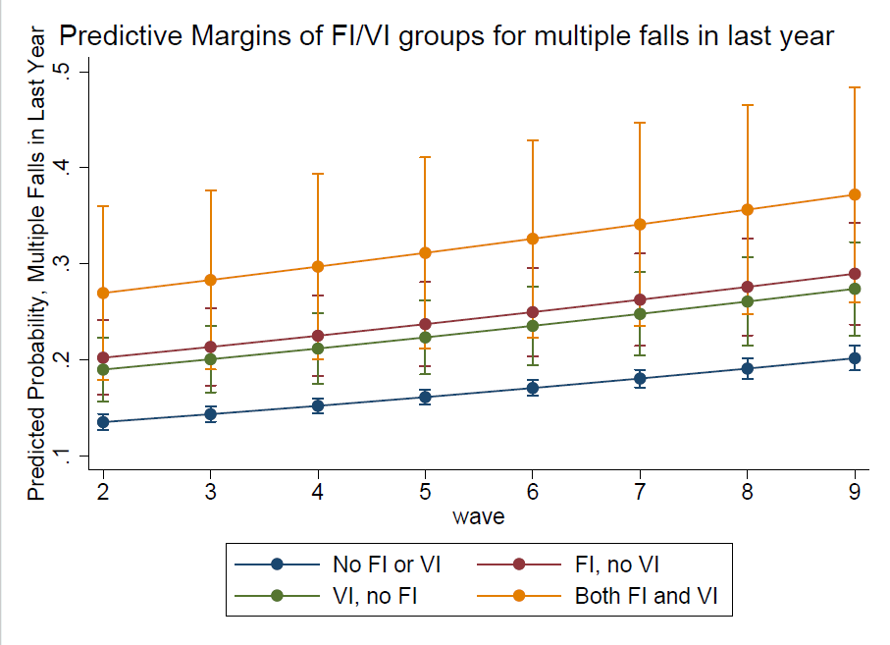

Supplementary Table 1. Baseline characteristics for the survey weighted population by food insecurity (FI) and vision impairment (VI) status, proportion or mean (SE)
 | No FI or VI | FI, no VI | VI, no FI | FI and VI | Total | p
Women | 0,4925 | 0,0188 | 0,0485 | 0,0066 | 0,5665 | <0.001
Age group
65-69 | 0,2114 | 0,0051 | 0,0078 | 0,0011 | 0,2254 | <0.001
70-74 | 0,2431 | 0,0077 | 0,0102 | 0,0019 | 0,263
75-79 | 0,1859 | 0,0061 | 0,0134 | 0,0018 | 0,2072
80-84 | 0,1341 | 0,0044 | 0,015 | 0,0012 | 0,1547
85-89 | 0,0804 | 0,0038 | 0,0138 | 0,002 | 0,0999
90+ | 0,0361 | 0,0014 | 0,0114 | 9,40E-04 | 0,0498
Race
White | 0,7332 | 0,0208 | 0,0508 | 0,0057 | 0,8105 | <0.001
Black | 0,0704 | 0,0028 | 0,0086 | 4,70E-04 | 0,0823
Other | 0,0873 | 0,0049 | 0,0122 | 0,0028 | 0,1072
Married | 0,8486 | 0,0261 | 0,0675 | 0,008 | 0,9501 | 0,053
Education
<HS | 0,1706 | 0,0093 | 0,0261 | 0,0043 | 0,2104 | <0.001
HS grad | 0,2498 | 0,0062 | 0,0209 | 0,0016 | 0,2785
>HS | 0,4704 | 0,013 | 0,0249 | 0,0028 | 0,5111
Total income
1 | 0,1275 | 0,0087 | 0,0202 | 0,0037 | 0,1602 | <0.001
2 | 0,1489 | 0,0092 | 0,0167 | 0,002 | 0,1768
3 | 0,1568 | 0,0036 | 0,0169 | 0,0018 | 0,1791
4 | 0,1987 | 0,0049 | 0,0115 | 9,40E-04 | 0,2161
5 | 0,259 | 0,0021 | 0,0063 | 4,80E-04 | 0,2679
Community dwelling | 0,8424 | 0,0258 | 0,0613 | 0,0069 | 0,9363 | <0.001
Body Mass Index classification
<18.5 | 0,0145 | 8,20E-04 | 0,0029 | 7,10E-04 | 0,0189 | <0.001
18.5-24.9 | 0,2977 | 0,0079 | 0,0259 | 0,0028 | 0,3342
25.0-29.9 | 0,3423 | 0,0096 | 0,0214 | 0,0022 | 0,3756
≥30.0 | 0,2403 | 0,0103 | 0,0179 | 0,0028 | 0,2713
Waist circumference | 39.6 (0.12) | 40.4 (0.63) | 40.3 (0.40) | 40.6 (1.03)
Overall health | 2.6 (0.02) | 3.8 (0.05) | 3.3 (0.06) | 3.9 (0.11)
Current smoker | 0,1251 | 0,0069 | 0,0144 | 0,0011 | 0,1475 | 0,014
Heart attack | 0,0228 | 0,0022 | 0,0025 | 0,001 | 0,0286 | <0.001
Heart disease | 0,1681 | 0,0088 | 0,0186 | 0,0029 | 0,1984 | <0.001
HTN | 0,5783 | 0,0216 | 0,0541 | 0,0069 | 0,6609 | <0.001
Diabetes | 0,213 | 0,0092 | 0,0241 | 0,0036 | 0,25 | <0.001
Stroke | 0,018 | 0,0012 | 0,0051 | 7,80E-04 | 0,025 | <0.001
Cancer | 0,0528 | 0,0017 | 0,0044 | 4,60E-04 | 0,0594 | 0,987
Dementia | 0,0383 | 0,0013 | 0,0132 | 5,20E-04 | 0,0534 | <0.001
Depression | 2.8 (0.02) | 4.3 (0.16) | 3.5 (0.08) | 4.4 (0.22)
Anxiety | 2.7 (0.02) | 4.3 (0.16) | 3.3 (0.08) | 4.6 (0.27)
Frail | 0,1004 | 0,0107 | 0,0188 | 0,0047 | 0,1345 | <0.001
Fall in last month | 0,0915 | 0,0074 | 0,0154 | 0,0032 | 0,1174 | <0.001
Fall in last year | 0,2065 | 0,0091 | 0,0198 | 0,0024 | 0,2378 | <0.001
Multiple falls | 0,3569 | 0,0282 | 0,0571 | 0,0127 | 0,4549
Sample size, n=5963, representing, n=33,346,365

