**Supplementary material Figure S1.** Example of a time–distance, time–velocity, and distance–velocity graph

**Supplementary material Figure S2.** Histogram of the acceleration phase

**Supplementary material Figure S3.** Relationship of the acceleration phase with age, usual gait speed, and physical performance  
(A) Relationship between the acceleration phase and age  
(B) Relationship between the acceleration phase and usual gait speed  
(C) Relationship between the acceleration phase and short physical performance battery (SPPB)

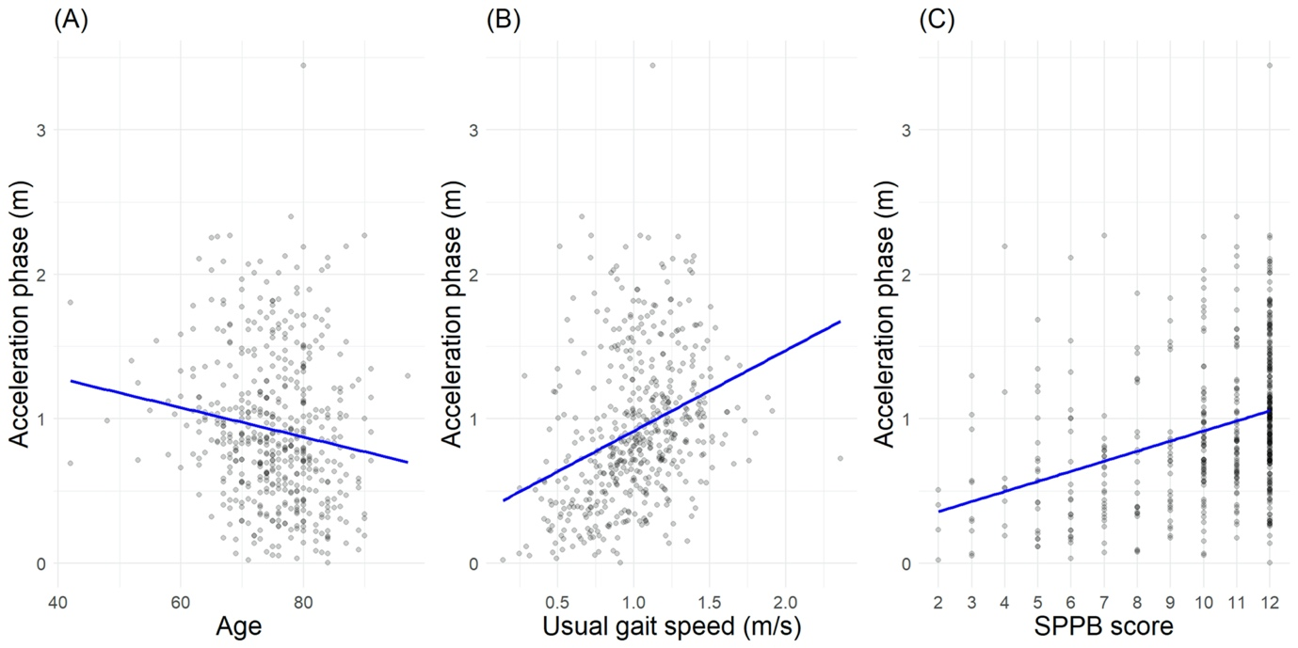

**Supplementary material Figure S4.** Relationship between the removed initial phase and the measured gait speed for 2 m in the long acceleration group (mean and standard deviation of the measured gait speed)

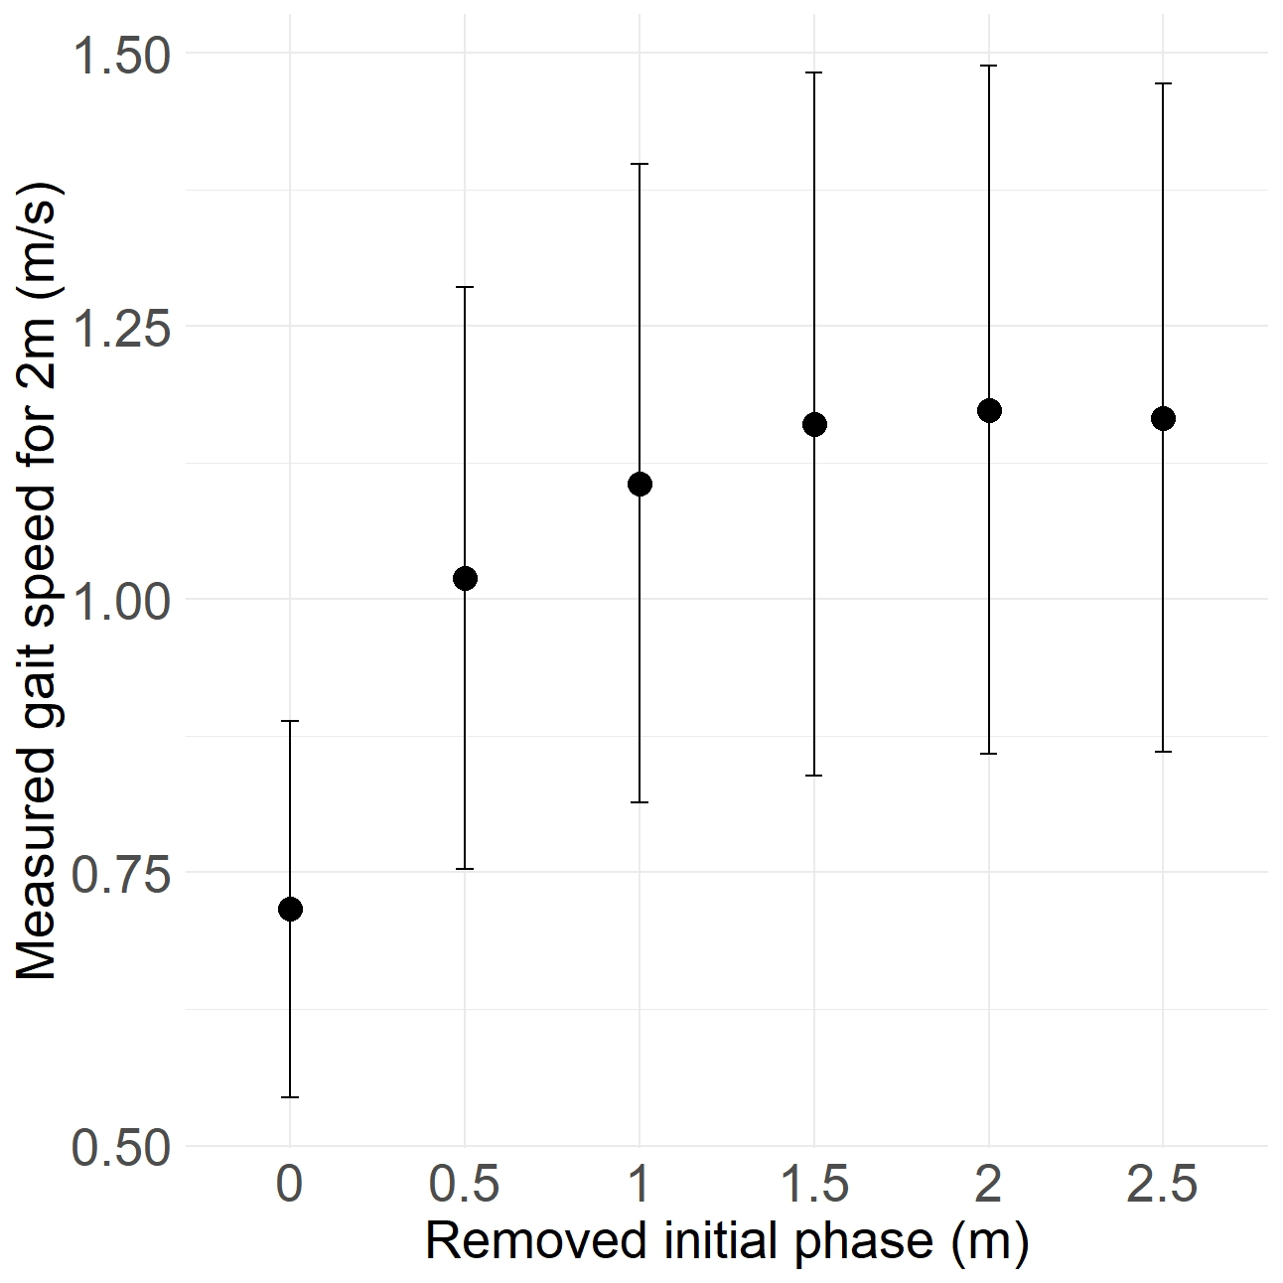

**Supplementary material Figure S5.** Distribution of the gait speed according to the methods of removing the initial phase  
(A) Gait speed based on the static method  
(B) Gait speed based on the dynamic method removing the initial 0.5 m  
(C) Gait speed based on the dynamic method removing the initial 1 m  
(D) Gait speed based on the dynamic method removing the initial 1.5 m

**Supplementary material Figure S6.** Association of SPPB Gait calculated based on each method with SPPB Balance + Chair Stand in the long acceleration group  
Note 1: Mean and standard deviation of the SPPB Balance + Chair Stand with linear regression plots.  
Note 2: R-squared values for each SPPB Gait method are provided; SPPB Gait Static, R2 = 0.47; SPPB Gait 0.5 m, R2 = 0.47; SPPB Gait 1 m, R2 = 0.48; SPPB Gait 1.5 m R2 = 0.51

**Supplementary material Table S1.** Baseline characteristics of included and excluded individuals

|  |  |  |  |
| --- | --- | --- | --- |
|  | **Included (n = 511)** | **Excluded (n = 124)** | **p-value\*** |
| Age | 75.3 ± 7.5 | 76.2 ± 7.4 | 0.22 |
| Female | 285 (55.8) | 69 (55.6) | 1.00 |
|  |  |  |  |
| SPPB | |  |  |
| SPPB score, total | 10.1 ± 2.5 | 9.4 ± 3.4 | 0.029 |
| SPPB score, gait speed | 3.5 ± 0.8 | 3.3 ± 1.2 | 0.026 |
| SPPB score, balance | 3.5 ± 0.8 | 3.3 ± 1.2 | 0.22 |
| SPPB score, chair stand | 3.2 ± 1.2 | 2.8 ± 1.4 | 0.024 |
|  |  |  |  |
| Gait pattern | |  |  |
| Usual gait speed (6 m to 2 m, m/s) | 1.01 ± 0.30 | 0.87 ± 0.48 | 0.003 |

Data are mean ± standard deviation or n (%)  
SPPB, Short Physical Performance Battery  
*Independent t-test p-values for continuous variables and Chi-squared p-values for categorical variables

**Supplementary material Table S2.** Relationship between the removed initial phase and the measured gait speed for 2 m (m/s) in the long acceleration group (n = 198)

|  |  |  |  |  |  |  |
| --- | --- | --- | --- | --- | --- | --- |
| **Removed initial phase (m)** | **0** | **0.5** | **1** | **1.5** | **2** | **2.5** |
| Mean gait speed | 0.72 | 1.02 | 1.12 | 1.16 | 1.17 | 1.17 |
| Standard deviation | 0.17 | 0.27 | 0.29 | 0.32 | 0.31 | 0.31 |
| p-value* | <0.001 | (Ref) | 0.002 | <0.001 | <0.001 | <0.001 |

* Independent t-test p-values with 0.5 m as the reference  
Ref, reference.