The Efficacy of 12-week Progressive Home-Based Strength and Tai-Chi Exercise Snacking in Older Adults: A Mixed-Method Exploratory Randomised Control Trial
- extended methods
Supplementary file B

Supplementary file B1 – Detailed methodology

Participants eligibility criteria
Interested participants were eligible to take part if they: (a) were 65 years of age or older, (b) were able to perform daily physical activity independently, determined by the Short Physical Performance Battery (SPPB, Guralnik, Simonsick, Ferrucci, Glynn, Berkman, Blazer, Scherr, Wallace ¹) test, (c) had impaired mobility (scored 2-6 out of 8 in the strength and balance domains of SPPB, without either section scoring zero), (d) were not regularly engaging in recreational sports or structured exercise (once a week or more). Furthermore, participants were deemed unable to take part if they had (a) any unstable chronic illness, cardiac, pulmonary, liver, or kidney abnormalities, uncontrolled hypertension, peripheral arterial disease, severe cognitive impairment, or major surgery in the previous 6 months, (b) a physical disability or underlying health condition that would exercise participation, (c) medical contraindications to exercise including chest pain, dizziness, or loss of consciousness, or who had been instructed by their doctors to only do physical activity recommended by them, (d) were unable to provide informed consent, or e) could not complete the physical function familiarisation test. Eligibility was ascertained through a preliminary online screening health questionnaire which also gathered participant demographic data.

Detailed randomisation
Participants were randomised to either the intervention group, or the control group (i.e. maintain habitual physical activity patterns), after baseline assessments were completed. Randomisation was performed using computer-generated blocked randomisation with a minimisation algorithm to balance groups by age and sex ², by a statistician who remained independent to any assessment or intervention delivery. Participants living in the same household were treated as one unit and randomised into the same group to avoid contamination between trial arms. As a behavioural intervention, participants were required to be aware of their allocated trial arm, but no deviations from the protocol were made for either intervention or control.

Familiarisation
All participants undertook an online familiarisation session via video call (using participants’ preferred software) to become accustomed to the physical function tests and undergo an exercise safety assessment. The subset of participants undertaking the laboratory-based assessment repeated the same familiarisation that they had performed remotely, with the addition of further measures of physical function.

Outcome measures
Psychological process measures
Participants completed an online baseline questionnaire assessing physical activity levels measured using the International Physical Activity Questionnaire-elderly (IPAQ-E, short form) ³, and the following psychological outcomes: the Multidimensional Outcome Expectations for Exercise Scale (MOEES) ⁴, the Behaviour Regulation Exercise Questionnaire (BREQ-3) ^{5,6}, perceived competence for exercise ⁷, the habit strength for exercise ⁸, and the self-efficacy for exercise (SEE) ⁹.

Health and wellbeing secondary outcomes
In addition to the psychological measures, the questionnaire pack also included scales to capture instrumental activities of daily living (IADL) ¹⁰ vitality using the Subjective Vitality Scale ¹¹, the Warwick-Edinburgh Mental Wellbeing Scales (WEMWBS) ¹², the EuroQoL five-dimension, five- level questionnaire (EQ-5D-5L) ¹³, the Satisfaction With Life Scale ¹⁴, the Short Form (SF-36) Health Survey ¹⁵.

Acceptability of the intervention: TFA survey and interview
Acceptability was measured with an 8-item online questionnaire based on the seven dimensions of TFA and a general overall assessment ¹⁶. Specifically, the framework focuses on how people feel about an intervention (affective attitude); the amount of effort the intervention requires (burden); how well the intervention relates to people’s beliefs and values (ethicality); how well the intervention was understood (coherence); whether or not other benefits needed to be given up to engage with the intervention (opportunity cost); whether people believed the intervention would work for them as intended (perceived effectiveness); and an individual’s confidence in their ability perform the intervention (self-efficacy). A Total score was calculated by summing the responses to each question, assigning scores of 1-5 to the response categories from "completely unacceptable," "no opinion," to "completely acceptable," ¹⁷. A higher score indicated greater acceptability to the exercise programme.

After the 12-week exercise and Tai-chi snacking intervention, semi-structured interviews were conducted in a subset of intervention participants. The topic guide was also based on the seven dimensions of TFA for understanding acceptability of the intervention. See Supplementary file pp 21 for the Interview Topic Guide.

Additional lab-based assessments
Lower limb strength and power were assessed via a 10-repetition incremental leg press test (A420, Keiser®, Fresno, CA) to establish force-velocity profile characteristics ¹⁸. Briefly, participants were asked to complete 10 discrete repetitions of leg pressing against increasing resistance up to their individual one-repetition maximum. Each repetition was required to be performed at maximum velocity, and increasing rest duration was permitted between each repetition.

Although we tested the 10-rep incremental test for mechanistic outcomes in the subset lab-based participants, some were not able to generate maximum concentric movement velocity across all repetitions (i.e., push as fast and hard on every rep) due to reasons such as being afraid of robotic gym-based machines, feeling unsafe performing the leg presses/pushing the pedals (especially those who had knee/hip replacements), and/or not knowing how to perform the pushes faster (not familiar with the performing rhythms) etc. Therefore, we could not extrapolate maximum force or velocity or interpolate maximum power in the leg press. Specifically, in 90 of 160 trials (56% of participants), it was not possible to generate force velocity profiles. This limitation may be attributed to the functional level and characteristics of our participants. Other studies examining older adults with similar functional level using the Keiser leg press have reported force velocity profiles ¹⁹⁻²¹. It's important to acknowledge that while previous studies have successfully reported force velocity data using the Keiser machine, the appropriateness of this equipment for interpreting power/force velocity profiles in our study context still requires further exploration. Researchers seeking to use the Keiser leg press machine in pre-frail older adults (a 4-8 SPPB population) need to consider these limiting factors.

Detailed statistical analysis
Power calculation
Using G*Power software we determined that based on finding an effect size of 0.5 (the mean difference in SPPB between intervention and control in previous study ²²) with 90% power and a significance alpha of 0.05, we required a sample size of 86. However, we utilised only the strength and balance domains of the SPPB, not the entire SPPB scale as these were deemed to have greater assumed reliability in a remote videocall format, and have better predictive utility on physical function outcomes ²³. The drop-out rate in our recent remote study ²⁴ was 19% and to allow for an anticipated higher attrition rate due to the longer duration of study we aimed for a total sample size of 102.

Quantitative data analysis
All analyses were performed using R version 4.1.2 (R Core Team 2021, R Foundation for Statistical Computing, Vienna, Austria). A linear mixed model (using the Ime4 package ²⁵) was used for all estimations, with sex, age, timepoints, and study groups included as fixed effects and participant ID included as a random effect to account for repeated observations. An interaction effect for ‘Time × Group’ was used to understand whether there was any difference in response over time between groups. Separate models were run for each outcome variable. Statistical significance was set as p<0.05.

Qualitative interview analysis
Digital recordings of interviews were transcribed verbatim in Microsoft Word in an anonymized format and then uploaded to QSR NVivo12 for coding and data organization. Data were analysed using a deductive framework analysis ²⁶ in line with aspects of the Theoretical Framework of Acceptability ¹⁷ to integrate participants’ perspectives on barriers and motivators to participation, future support, and any opportunities to improve the protocol.

Supplementary file B2 – Exercise instructions
Exercise snacking
What is exercise snacking?

This is a method of doing exercise into short bouts at a time that is convenient for you. We are asking you to try this daily short exercise snacking routine, which will include 5 minutes of exercise and 1 minute of rest between each exercise, every day for the next 12-weeks. The exercise programme is progressive and has three levels. You can progress to the next level on any type of exercise if you pass the progress criteria and when you feel you are ready. The exercises themselves are safe for the home and don’t require a warm-up before starting. The exercises do not require any sports clothing or equipment; just a kitchen chair and a clock or watch to time your exercise with.

How is the exercise performed?

During each exercise bout, spend one minute performing each of the five exercises detailed below. Complete repetitions of each exercise at a self-selected pace that you can maintain for the full minute, with the aim being to complete as many repetitions as possible in that minute. If your muscles begin to feel unduly sore during the any of the exercises, you may of course slow down or indeed stop that exercise at that time. Take one minute between each exercise to rest.

What are the risks of performing the exercise?
As with any exercise, you are likely to feel tired towards the end of the session and in the time straight afterwards. However, the principle of exercise snacking is that the bouts should not be excessively demanding, with each exercise of the regime performed for only one minute at a self-selected repetition speed. The primary risk when performing the exercise is loss of balance during the standing exercises. This risk can be mitigated by performing the movements at a controlled pace, and by holding onto a stable object such as a chair, table, or door frame. This exercise regime has been designed specifically to avoid excessive cardiovascular load, as might be experienced during running, but you may still notice your breathing rate increase during the exercise. If your muscles begin to feel unduly sore during the any of the exercises, you may of course slow your repetition pace down or indeed stop that exercise at that time.
We recommend starting with all the level 1 exercises when you begin the programme. If you think any of the exercises are too easy for you, and you are finding yourself consistently meeting the progression criteria we have described in the table below, then you can try the next level exercise for that movement. You do not need to progress in each, or any, of the activities at the same time and should only ever do 5 exercises in total as part of your exercise snacking bout for the day. We ask that you mark down which 5 exercises you do on your exercise logbook and record the number of repetitions you do in the minute for each exercise.
Table S1. exercise snacking movements
Types of exercise | Exercise | Level 1 | Level 2 | Level 3
Exercise snacking (strength) | ES1  Sit-to-stand | ES1.1  Sit-to-stand  (free arms) | ES1.2  Sit-to-stand  (arms across chest) | ES1.3  Air squat
 | Entry Criteria | NA | 10 reps minimum | 10 reps minimum
 | Progress criteria | No longer need arms | >45 reps | NA
 | ES2  Shoulder exercise  (straight arms) | ES2.1  Seated hip-to-hip arch overhead | ES2.2  Seated wood chop | ES2.3  Seated figure 8's
 | ES3  Single leg | ES3.1  March on the spot | ES3.2  Single leg split squat | ES3.3  Reverse lunge
 | Entry Criteria | NA | 5 reps per leg | 5 reps per leg
 | Progress criteria | No feeling of stimulus | 12 reps per leg | NA
 | ES4  Arm exercise | ES4.1  Seated arm cross | ES4.2  Seated front raise to overhead | ES4.3  Multidimensional arm raise
 | ES5  Ankle exercise | ES5.1  Seated calf raise | ES5.2  Standing calf raise | ES5.3  Single leg calf raise
 | Entry Criteria | NA | 15 reps minimum | 15 reps minimum
 | Progress criteria | 30 reps | >45 reps | NA

- Level 1 exercise snacking movements
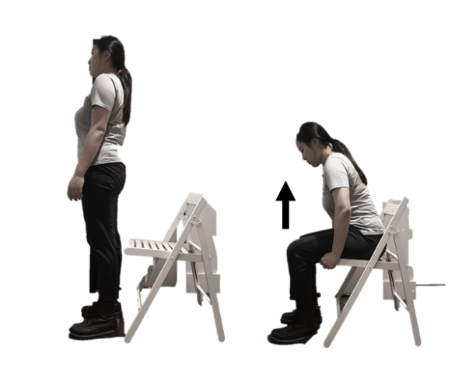
  - ES1.1 Sit-to-stand (free-arms): This exercise is simply repetition of rising from an up-right seated position on a kitchen chair, and then returning to the seated position. You can use your arms for aid out of the chair.

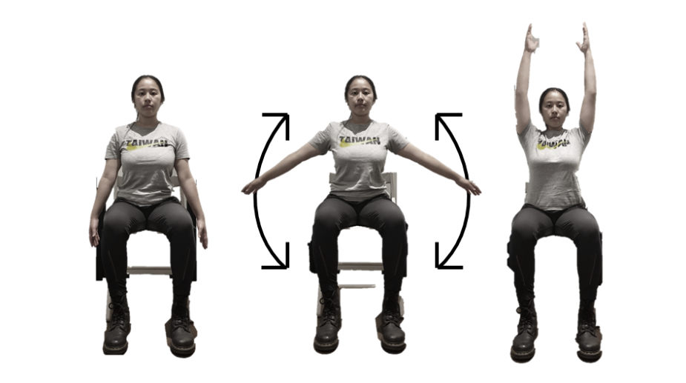
    - ES2.1 Seated hip-to-hip arch overhead: Starting from an up-right seated position on a kitchen chair with hands by your side. Keep your elbows slightly flexed whilst raising hands up laterally until arms by your ears. Return to the start position at a controlled pace, and repeat the movement.

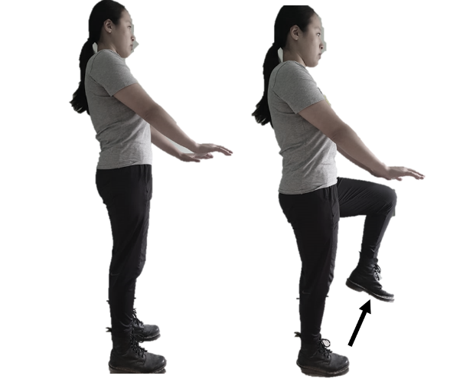
  - ES3.1 March on the spot: Standing up-right, put your arms out in front of you and your hands roughly at waist height. Raise one leg up by bending your knee and hip as per the diagram, aiming to get your thigh as close to horizontal as possible, with the top of your thigh touching your hands. At a controlled pace, return to a standing position, regain balance if necessary, and repeat with the other leg. If you struggle with balance, you can hold onto something stable like the back of a chair or a door frame with one hand.
- ES4.1 Seated arm cross: Start by sitting up-right in a chair with arms by your side. Keeping your arms straight, raise your hands up in front of you until arms are parallel to floor, and then cross your arms so each hand touches the opposite shoulder. Uncross your arms whilst keeping them straight out in front of you, then return to arms by side.
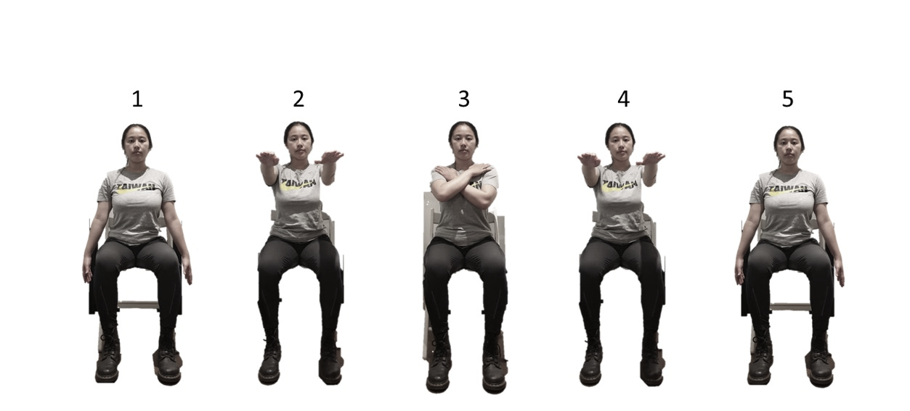

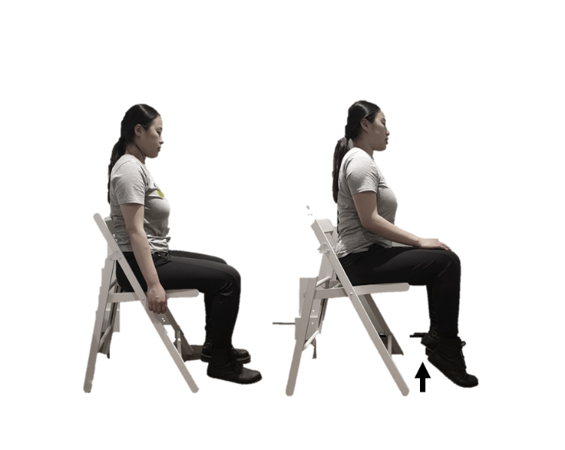
  - ES5.1 Seated calf raise: Sitting up-right in a chair, start with your feet flat on the floor and rise up onto your tiptoes as high as you can, then return to the start position with feet flat on the floor. Perform the raises on both legs at the same time and try to complete as many as you can in a minute.

- Level 2 exercise snacking movements
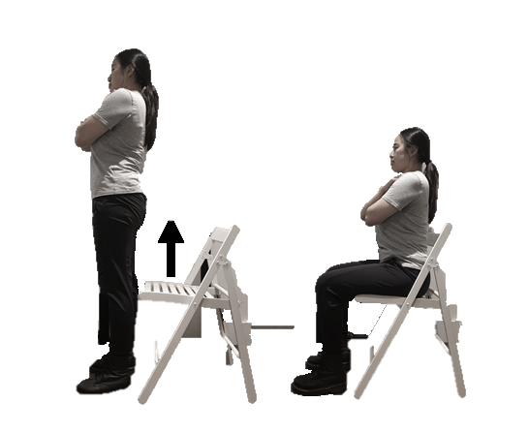
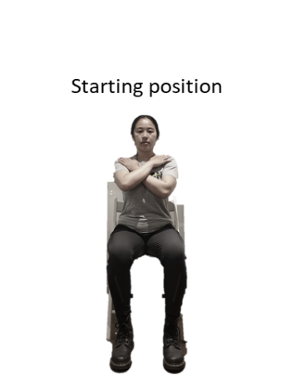
  - ES1.2 Sit-to-stand (arms across chest): This exercise is simply repetition of rising from an up-right seated position on a kitchen chair, and then returning to the seated position. Try to keep your arms folded across your chest to avoid using your arms to aid rising from the chair, making sure that your legs are doing the work.

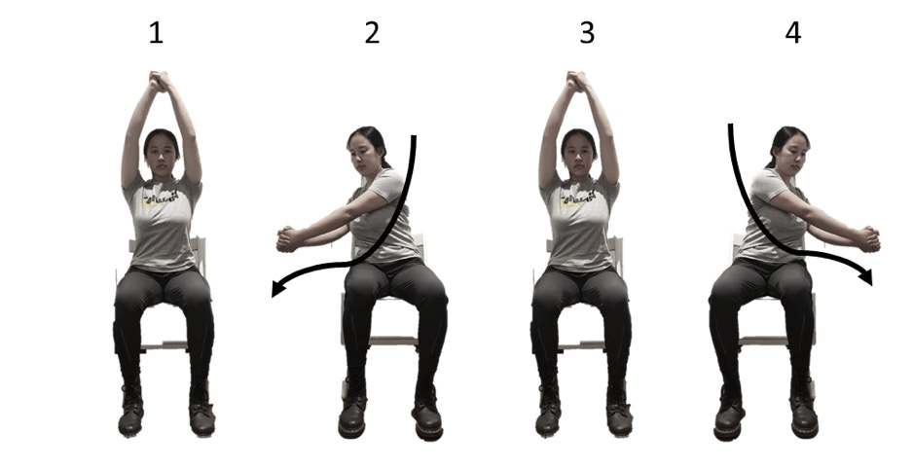
    - ES2.2 Seated wood chop: Start with your hands together and your arms raised above your head. Keeping your hands together and arms straight, bring your hands diagonally down across the body, rotating your torso, until your hands are close to your hip. Return to the start position and repeat the movement with hands going towards the other hip.

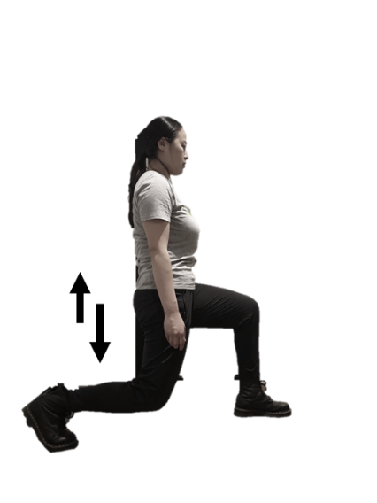
  - ES3.2 Single leg split squat: Stand with feet far apart, one foot forward and other foot behind. Squat down by flexing knee and hip of front leg. Allow heel of rear foot to rise up while knee of rear leg bends slightly until it almost makes contact with floor, or the thigh of your front leg is parallel to the floor. Return to original standing position by extending hip and knee of forward leg. Do 30 seconds for each side. If you struggle with balance, you can hold onto something stable like the back of a chair with one hand.
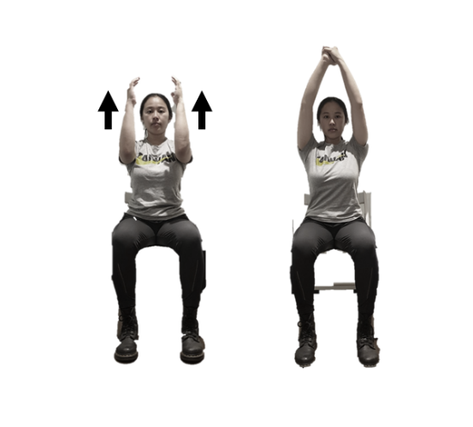
    - ES4.2 Seated front raise to overhead: Starting from an up-right seated position on a kitchen chair with arms straight down by your side. Raise your arms in front of you, bending your elbows as you do so, and then reach your arms up over head until your elbows are straight again, and your hands touch together. Return to the starting position in a controlled pace and repeat the movement.
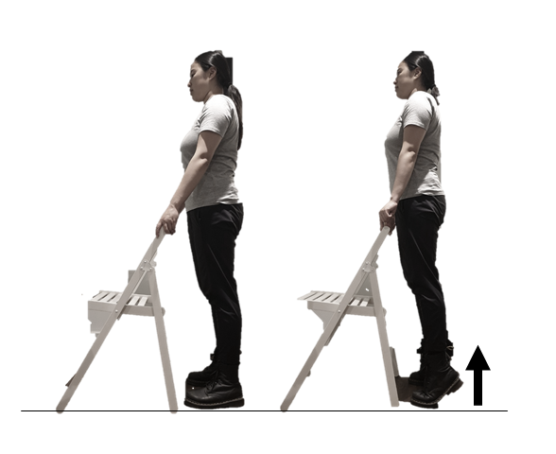
  - ES5.2 Standing calf raise: Start with your feet flat on the floor and rise up onto your tiptoes as high as you can, then return to the start position with feet flat on the floor. It is advisable to hold onto something stable like a chair, table, or door frame to maintain balance. Perform the raises on both legs at the same time and try to complete as many as you can.
- Level 3 exercise snacking movements

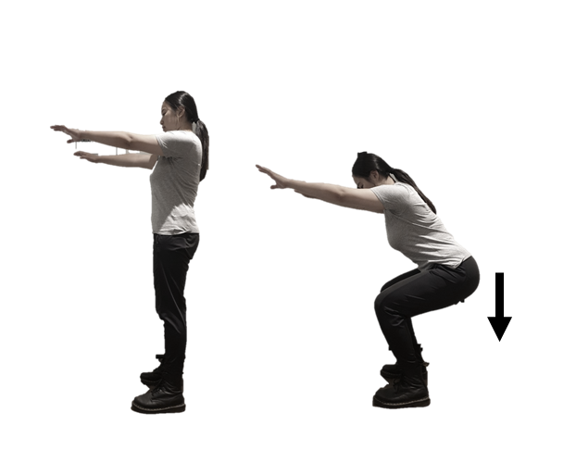
  - ES1.3 Air squat: Stand with your feet shoulder-width apart and keep your toes pointing slightly outward. Slowly squat down as if you were about to sit on a chair. Aim to keep your feet flat on the floor and maintain balance without leaning forward excessively. When squatting, your hips will move down and back, and you should aim to keep your back straight. When your knees are at right angles, stand up straight again in a controlled pace, and then repeat the movement.
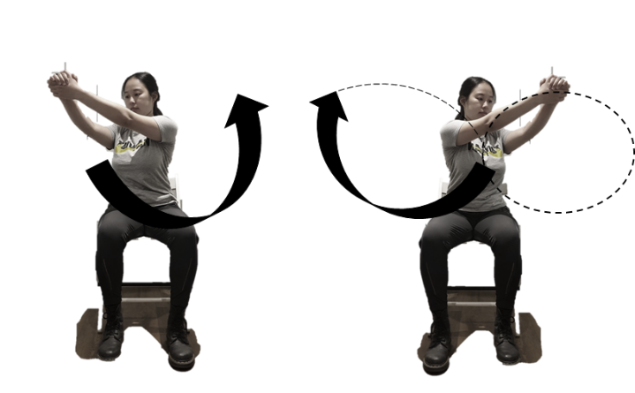
    - ES2.3 Seated figure 8’s: Hold your hands together with your arms straight out away from your body. Slowly move your arms in a continuous motion forming the pattern of the number 8 on its side (‘a figure of 8’). Repeat the movement in one direction for 30 seconds and then continue the exercise for 30 seconds forming the figure of 8 in the opposite direction.

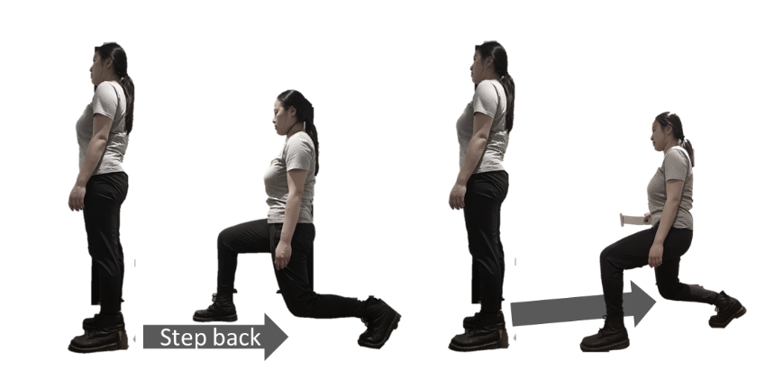
  - ES3.3 Chair reverse lunge: Stand straight with feet shoulder-width apart. Looking forward, take a step backward and lower your body by flexing your hips and knees. With your back leg making contact through the ball of the foot, move your hip downward close to the floor, and then go back to the initial position by pushing through the heel of your front leg, regain balance if necessary, and repeat with the other leg. If you struggle with balance, you can hold onto something stable like the back of a chair with one hand.

- ES4.3 Multidimensional arm raises: Start in an up-right seated position on a kitchen chair with your arms down by your side. Keeping your arms straight, raise your hands up and out to the sides until your arms are parallel to floor. Bring your arms round so they are straight out in front of you, then raise your arms straight up over your head. Lower your arms so they are straight out in front of you, then bring your arms back up and out the sides, and then return your arms to the start position down by your side.
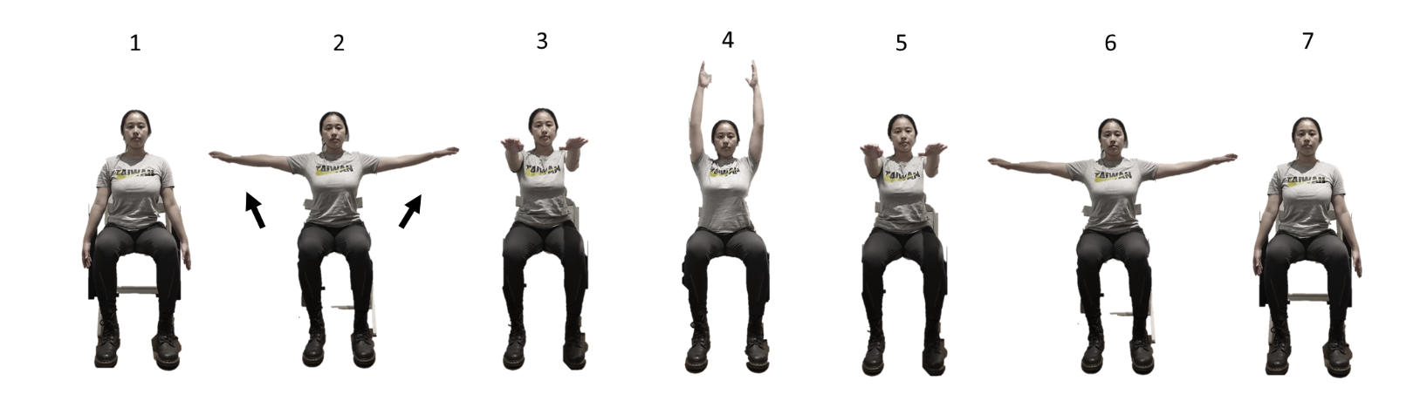

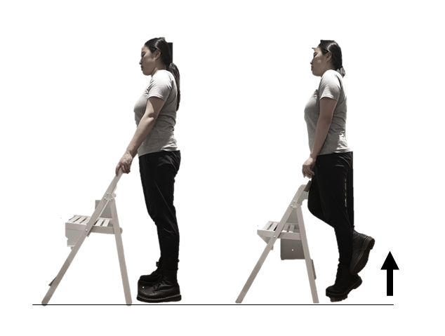
  - ES5.3 Single leg calf raise: Start with your feet flat on the floor and rise up your left heel onto your tiptoes as high as you can, then return to the start position with feet flat on the floor and repeat with the other leg (rise up your right heel), and repeat the movements alternatingly. If you struggle with balance, you can hold onto something stable like the back of a chair with one hand.
Tai-chi snacking
What is Tai-chi?
Tai-chi combines deep breathing and relaxation with flowing movements. Unlike the Exercise snacking plan, the goal is not to complete the movements as fast as possible but perform them in a slow and controlled way. The Tai-chi snacking programme is progressive and has three levels. You will start from practicing basic balance movements and progress to higher levels which the movements are inspired by the principles of Tai-chi. We are asking you to try this short Tai-chi routine, which will include 5 minutes of exercises and 1 minute of rest between each exercise, every day for the next 12-weeks. The exercises themselves are safe for the home and don’t require a warm-up before starting. The exercises do not require any sports clothing or equipment; just a kitchen chair or other suitable surface in case you feel you need extra support while performing the movements.

How is the exercise performed?
During each exercise bout, spend one minute performing each of the five exercises detailed below. Complete repetitions of each exercise at a self-selected pace that is comfortable for you to maintain for the full minute, with the aim being to complete them as accurately and smoothly as possible (based on correct posture and proper alignment). If your legs begin to feel sore during the any of the exercises, you may of course stop that exercise. Make sure you take one minute of rest between each exercise.

What are the risks of performing the exercise?
As with any exercise, you might feel tired towards the end of the session and in the time right afterwards. However, the principle of Tai-chi is that the movements should not be too demanding, with each exercise of the routine performed for only one minute at a self-selected repetition speed. The primary risk when performing the exercise is loss of balance. This risk can be mitigated by performing the movements at a controlled speed, and by holding onto a stable object such as a chair, table, or door frame if required. This exercise regime has been designed specifically to avoid any cardiovascular load, as might be felt during running or other strenuous exercise. If your legs begin to feel overly sore during the any of the exercises, you may of course stop that exercise at that time.
We recommend starting with all the level 1 exercises when you begin the programme. If you think any of the exercises are too easy for you, and you are finding yourself being in complete control and not losing your balance throughout the 60 seconds, then you can try the next level exercise for that movement. You do not need to progress in each, or any, of the activities at the same time and should only ever do 5 exercises in total as part of your Tai-chi snacking bout for the day. We ask that you mark down which 5 exercises you do on your exercise logbook.

Table S2. Tai-chi snacking movements
Types of exercise | Exercise | Level 1 | Level 2 | Level 3
Tai-chi snacking (Balance) | TC1  Single leg squat | TC1.1  Single leg tiptoe squat | TC1.2  Heel tipping | TC1.3  Playing the lute
 | TC2  Trunk rotation | TC2.1  Grasp the sparrow’s tail | TC2.2  White crane spreads wings | TC2.3  Cloud hand
 | TC3  Single leg stand | TC3.1  Front knee kick | TC3.2  Stand on one leg | TC3.3  Front heel kick
 | TC4  Hip and knee exercise | TC4.1  Open Tai-chi | TC4.2  Open Tai-chi (with calf raise) | TC4.3  Open Tai-chi (with calf raise and heel stand)
 | TC5  Ankle mobility | TC5.1  Heel-toe rotation | TC5.2  45⁰ forward ankle exercise | TC5.3  Slant fly

- Level 1 Tai-chi snacking movements

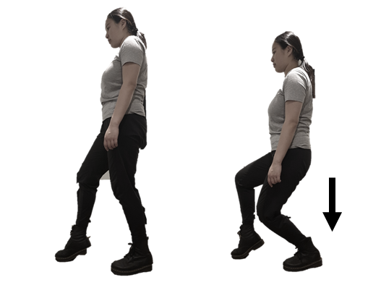
  - TC1.1 Single leg tiptoe squat: Start in a standing position, shift your weight to your left leg; lift the heel of your right foot off the ground and then squat down by bending your left knee and hip in a slow steady movement before coming back up. Repeat for 30 seconds on the left leg and then swap to do the same movement for 30 seconds on the right. If you struggle with balance, you can hold onto something stable like the back of a chair.

- TC2.1 Grasp the sparrow’s tail: Raise one arm forwards and turn the palm to face the middle of your chest, imagining that you are holding a large ball against your body. Bring the other hand forward to just in front of your tummy, palm facing upwards, as though you were supporting the ball from below. Circle the hand of the first arm inwards, downwards and then forwards, ending up with the fingers facing forwards, palm down. Imagine that you are holding a long object between your two hands (the “sparrow’s tail”). Bring both arms downwards and backwards to the side of the bottom hand, keeping the same distance between the arms. Repeat the movement with the opposite way in a continuous motion forming the pattern of the number 8 (figure 8).
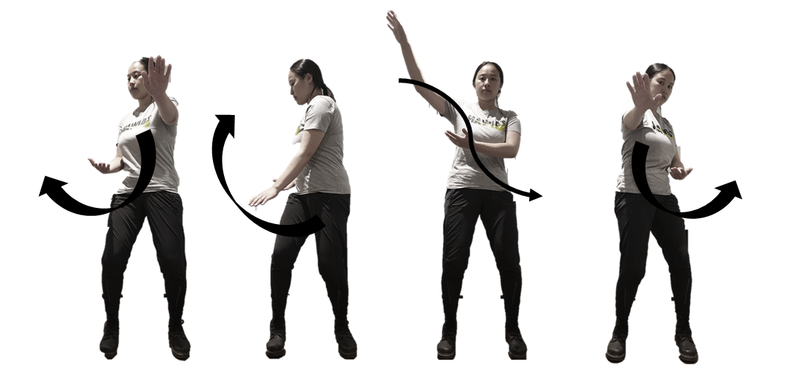

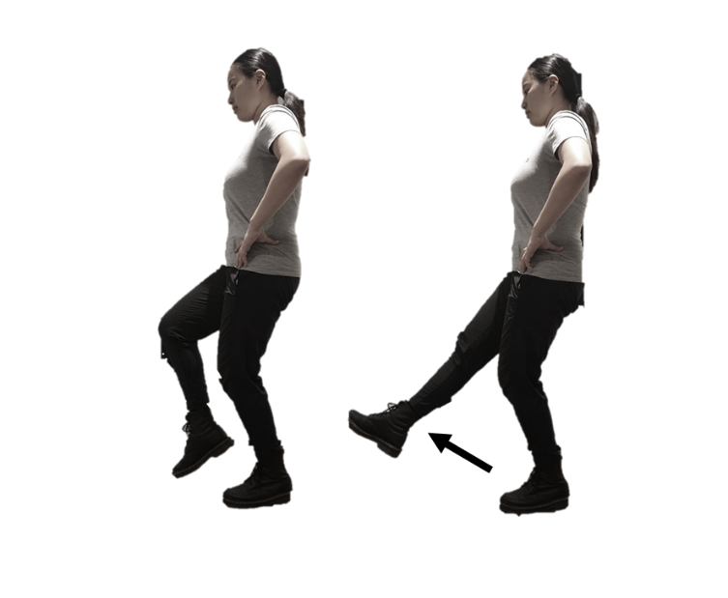
  - TC3.1 Front knee kick: Keep your weight on left leg and remain stable, raise your right knee, then kicking the right leg forward slowly. Aim to kick your leg in a controlled manner. Regain your balance if necessary and continue doing right leg kicking for 30 seconds. Then shift your weight to stand on your right leg and complete left leg kicks for 30 seconds. If you struggle with balance, you can hold onto something stable like the back of a chair with one hand.
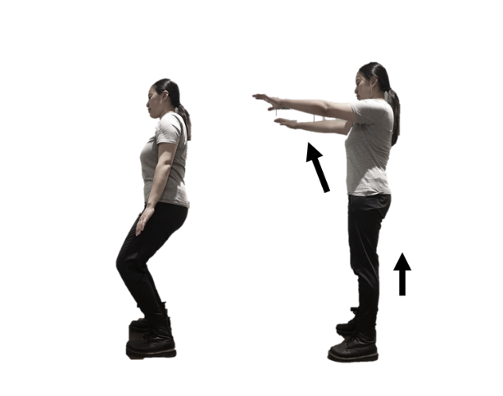
    - TC4.1 Open Tai-chi: Standing with your knees slightly bent, feet shoulder-width apart and facing forward with hands by your side. Keep your arms straight and raise them in front until parallel to the floor, straightening your legs at the same time. Then return to your side and bend your knees slightly to return to the start position.

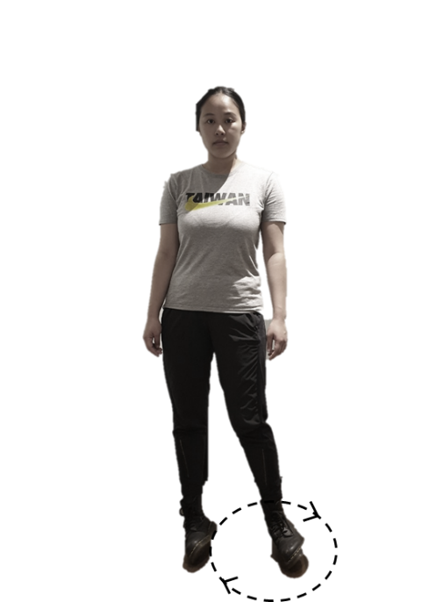
  - TC5.1 Heel-toe rotation: Start by standing with your knees slightly bent, feet shoulder-width apart and facing forward. Raise your heels off the floor, then rotate your ankle and make the outside of your right foot and inside of your left foot touch the ground, and then keep rotating your ankles clockwise to shift your weight so that your outside of the left foot and inside of the right foot are now touching the floor (you can lean forward a little to maintain your balance). Continue rotating clockwise for 30 seconds and then repeat in the opposite direction for 30 seconds more (counterclockwise). You may wish to have a solid surface to hold on to nearby as you start this exercise.
Level 2 Tai-chi snacking movements

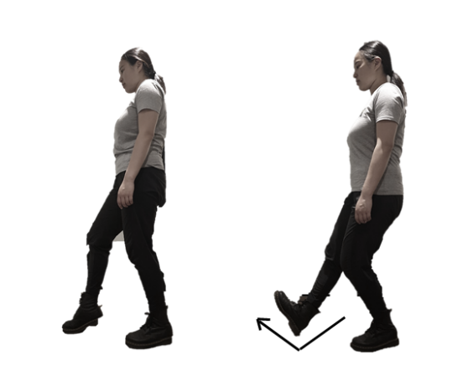
  - TC1.2 Heel tipping: Start in a standing position, shift your weight to left leg; tip the right heel in front with your left knee slightly bent. Repeat the movement in a slow and controlled way on your left leg for 30 seconds, then swap and do the right leg for 30 seconds. If you struggle with balance, you can hold onto something stable like the back of a chair.

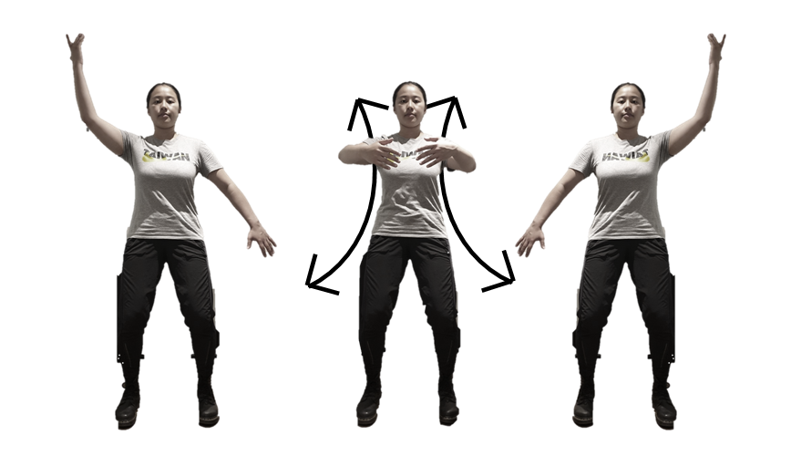
    - TC2.2 White crane spreads wings: Standing with your knees slightly bent, feet shoulder width apart and facing forward with hands by your side. Raise your right arm up at your face height with palm facing yourself, and then swing your arms in front of your chest to bring your left arm up at face height and your right arm down by your side with palm facing backward. Your arms should move in the opposite direction from one another in a slow and controlled rhythm. Repeat the movement for one minute.

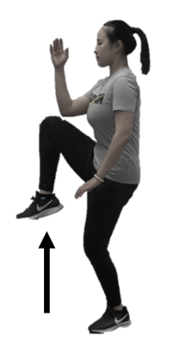
- TC3.2 Stand on one leg: Start in a standing position with your hands by your side. Shift your weight to left leg; lift the right heel off the ground and then raise your right leg off the floor and raise your right arm with your hand facing inwards in a slow steady movement. Keep your left knee slightly bent and left arm by your side. Aim to get your right thigh as close to horizontal as possible, then return that foot to the floor, regain your balance if necessary, and repeat for 30 seconds with your left leg on the ground, then swap and do 30 seconds of left leg and arm raises with the right leg on the ground. If you struggle with balance, you can hold onto something stable like the back of a chair.
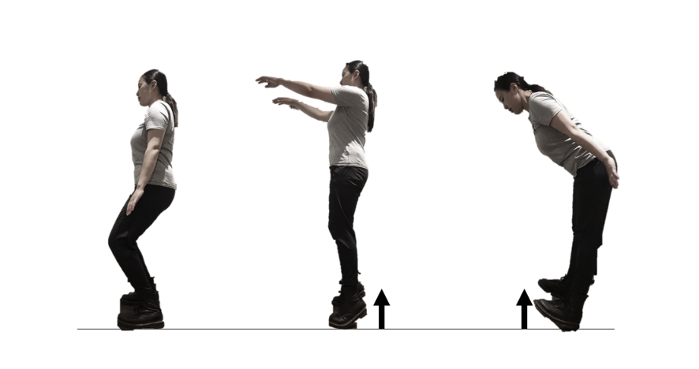
    - TC4.2 Open Tai-chi (with calf raise): Stand with feet shoulder width apart and facing forward with hands by your side. Raise your arms in front and rise your heel up at the same time so you are standing on your toes with your arms stretched out in front of your face and palms facing the floor. Return your heels to the floor and arms back to your side in a slow motion and repeat this movement for one minute.

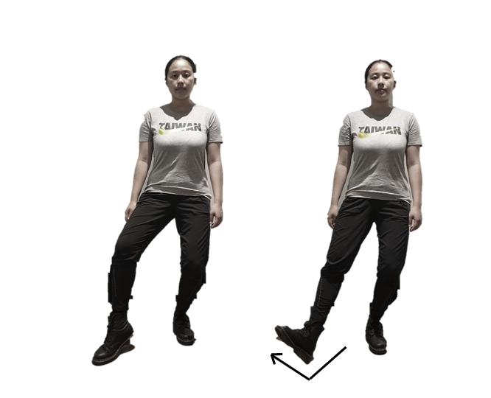
  - TC5.2 45⁰ forward ankle exercises: Stand with knees slightly bent. Move your right foot forward and to the side a little so you can tap the ground with that toe (start from single leg tiptoe). Next, with this leg still a little in front, tap the heel to the floor. Do the consecutive heel then toe tap for 30 seconds and then repeat on the left foot for a further 30 seconds.

- Level 3 Tai-chi snacking movements

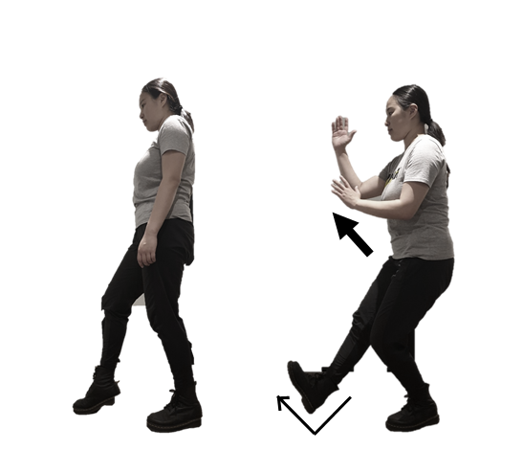
  - TC1.3 Playing the lute: Start in a standing position, shift your weight to left leg; tip the right heel in front and bring your hands up in front of you (right hand at nose height and left hand at chest height), and have palms facing inward at the same time with your left knee slightly bent. Repeat the movement in a slow and controlled way on your right leg for 30 seconds, then swap and do the left leg for 30 seconds.

- TC2.3 Cloud hand: Standing with your knees slightly bent, feet shoulder width apart and facing forward with left palm facing you at shoulder height and right palm facing the floor at waist height. Cross the arms from right to left, turn your palms to have your left palm face the floor and right palm face you, change arms so the right is on top, and left at waist height. Turn your body so you face to the right as you perform the movement, then cross your arms from left to right, turn your palms, change arms and turn the body back to the left. Repeat the movement turning from left to right and crossing hands for one minute.

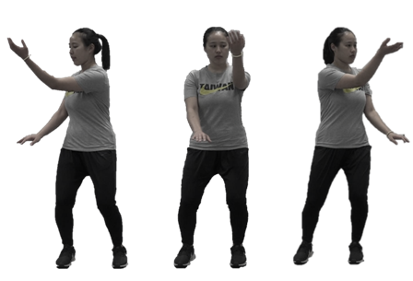

- TC3.3 Front heel kick: From a standing position with your hands cross, sit gradually into the left hip and lift your right heel slightly off the ground. Try to keep your weight on left leg and remain stable while raising your right leg with your knee bent, then kicking the right leg forward slowly and open your arms outwards at the same time. Aim to kick your leg slowly in a controlled manner as high as possible, then slowly return that foot to the floor. Regain your balance if necessary and repeat for 30 seconds on the right leg, then shift your weight to the right leg and repeat the kicking movement with your left leg for 30 seconds. If you struggle with balance, you can hold onto something stable like the back of a chair with one hand.

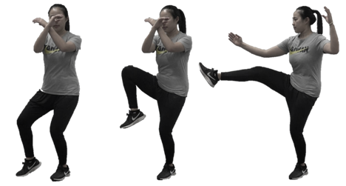

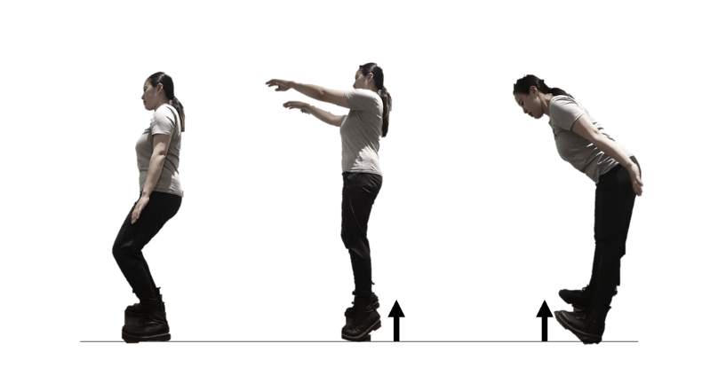
    - TC4.3 Open Tai-chi (with calf raise and heel stand): Stand with feet shoulder width apart and facing forward with hands by your side. Raise your arms in front and rise your heel up at the same time so you are standing on your toes. Then bring your arms back by your side in a slow and controlled manner and shift your weight back on to your heels so that when your arms are by your side your toes are off the ground. Repeat this motion returning to a flat foot starting position in between each go if necessary to regain balance. Otherwise, you can try to move from heels to toes and back again in one fluid movement while moving your arms up and down.
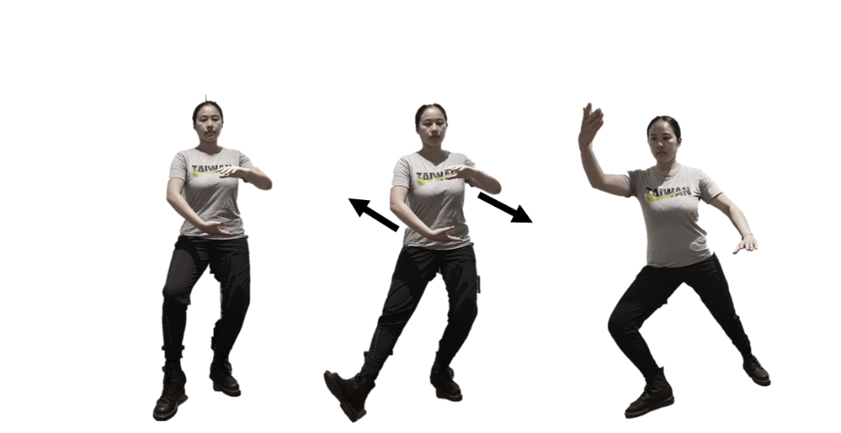
  - TC5.3 Slant fly: Sit slightly into your left hip and then lift your right heel off the ground with hands in front of you (left hand in line with your chest facing the floor, and right hand in line with your waist, facing up). Your right foot should then take a step out in front and to the right of you while you bring your right hand up to shoulder height, palm facing up, and bring your left hand down to be in line with your hip, palm facing down, at the same time. Regain your balance if necessary and repeat for 30 seconds on the right leg, then shift your weight to the right leg and rotate your hands (having your right hand in line with your chest facing the floor, and left hand in line with your waist, facing up) and repeat the movement with your left leg for 30 seconds.

Supplementary file B3 – TFA survey
Assessing Acceptability – the Theoretical Framework of Acceptability questions
General Acceptability: How acceptable did you find your exercise programme over the past 4 weeks?
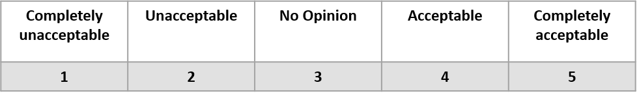Affective attitude: How much did you like doing your exercise programme?
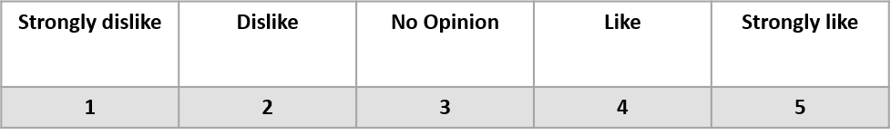
Burden: How much effort did it take for you to follow the exercise programme?
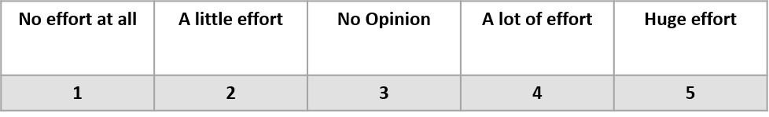Ethicality: how fair you think other people like you will find the exercise programme?
Very unlikely | Likely | No Opinion | Likely | Very likely
1 | 2 | 3 | 4 | 5
Perceived effectiveness: How likely is it that the programme has helped you stay fit and strong?
Very unlikely | Likely | No Opinion | Likely | Very likely
1 | 2 | 3 | 4 | 5
Opportunity costs: Continuing with this exercise programme would interfere with my other priorities.
Very unlikely | Likely | No Opinion | Likely | Very likely
1 | 2 | 3 | 4 | 5
Self-efficacy: How confident are you that you can keep doing the exercise programme?
Very unlikely | Likely | No Opinion | Likely | Very likely
1 | 2 | 3 | 4 | 5
Intervention coherence: It is clear to me how doing this exercise programme would help my strength and balance.
Very clear | Clear | No Opinion | Unclear | Very unclear
1 | 2 | 3 | 4 | 5

Supplementary file B4 – TFA interview topic guide

Thank you once again for taking part in the Exercise snacking and Tai chi intervention study. This short interview is designed to get a richer understanding of your experience of the programme you have been asked to follow over the past 12 weeks, and an opportunity to provide us with feedback that will help us improve this programme in the future. Please remember there is no right or wrong answers, you can be as critical as you like as all feedback is useful to myself and the research team in understanding how useful and effective our exercise and tai chi snacking programme can be.
Experiences of the intervention
- How did you find the exercise programme on the whole?
- What, if any, do you feel were the benefits of doing the programme for you personally?
- Which element of the programme did you find the most useful? Why?
- Which element of the programme did you find the least useful? Why?
- When completing the exercises, how did it make you feel?
  - During the activity itself, or afterwards?
- Did you find any elements particularly difficult?
  - Were any aspects of the exercise snacking particularly challenging?
  - Were any aspects of the Tai-chi snacking particularly challenging?
- How easy did you find it to stick the programme?
  - Did you always feel motivated to complete the exercises? [Why not?]
  - Do you feel the programme became part of your routine?
- Did anything ever prevent you from being able or wanting to do the programme?
  - What was the biggest obstacle to doing the exercise every day, if any?
- Was there anything you did to make the programme easier to do for you?
  - e.g., change the environment/ set reminders/ do it with a friend?
- How did you find undertaking the online assessments? Do you think it was easy to run the assessments? Any technological difficulties?
Future suggestions
- Having completed the programme what might you do going forward in terms of exercise?
  - Will you continue to do the programme/ any aspects of it?
  - Is there anything else you would like to try?
- What might make the programme even more useful or enjoyable if you were continue doing it?
- Is there any additional support you might like if you were doing this again or in the future? (E.g., support from coach, equipment, videos)
Supplementary references
1. Guralnik JM, Simonsick EM, Ferrucci L, et al. A short physical performance battery assessing lower extremity function: association with self-reported disability and prediction of mortality and nursing home admission. Journal of gerontology. 1994;49(2):M85-M94.
2. Hopkins WG. Assigning Subjects to Groups in a Controlled Trial. Sportscience. 2017;21.
3. Hurtig-Wennlöf A, Hagströmer M, Olsson LA. The International Physical Activity Questionnaire modified for the elderly: aspects of validity and feasibility. Public health nutrition. 2010;13(11):1847-1854.
4. Resnick B, Zimmerman SI, Orwig D, Furstenberg A-L, Magaziner J. Outcome Expectations for Exercise Scale: Utility and Psychometrics. The Journals of Gerontology: Series B. 2000;55(6):S352-S356.
5. Wilson PM, Rogers WT, Rodgers WM, Wild TC. The psychological need satisfaction in exercise scale. Journal of Sport and Exercise Psychology. 2006;28(3):231-251.
6. Markland D, Tobin V. A modification to the behavioural regulation in exercise questionnaire to include an assessment of amotivation. Journal of Sport and Exercise Psychology. 2004;26(2):191-196.
7. Williams L, Gill DL. The role of perceived competence in the motivation of physical activity. Journal of Sport and Exercise Psychology. 1995;17(4):363-378.
8. Verplanken B, Orbell S. Reflections on past behavior: a self‐report index of habit strength 1. Journal of applied social psychology. 2003;33(6):1313-1330.
9. Resnick B, Jenkins LS. Testing the reliability and validity of the self-efficacy for exercise scale. Nursing research. 2000;49(3):154-159.
10. Lawton MP, Brody EM. Assessment of older people: self-maintaining and instrumental activities of daily living. The gerontologist. 1969;9(3_Part_1):179-186.
11. Ryan RM, Frederick C. On energy, personality, and health: Subjective vitality as a dynamic reflection of well‐being. Journal of personality. 1997;65(3):529-565.
12. Tennant R, Hiller L, Fishwick R, et al. The Warwick-Edinburgh mental well-being scale (WEMWBS): development and UK validation. Health and Quality of life Outcomes. 2007;5(1):1-13.
13. Herdman M, Gudex C, Lloyd A, et al. Development and preliminary testing of the new five-level version of EQ-5D (EQ-5D-5L). Quality of life research. 2011;20:1727-1736.
14. Diener E, Emmons RA, Larsen RJ, Griffin S. The satisfaction with life scale. Journal of personality assessment. 1985;49(1):71-75.
15. Ware J, Kosinski M, Keller S. SF-36 physical and mental health summary scales. A user's manual. 2001:1994.
16. Sekhon M, Cartwright M, Francis JJ. Development of a theory-informed questionnaire to assess the acceptability of healthcare interventions. BMC health services research. 2022;22(1):279.
17. Sekhon M, Cartwright M, Francis JJ. Acceptability of healthcare interventions: an overview of reviews and development of a theoretical framework. BMC health services research. 2017;17(1):1-13.
18. Samozino P. Optimal force-velocity profile in ballistic moveme. 2012.
19. Shea MK, Fielding RA, Dawson-Hughes B. The effect of vitamin D supplementation on lower-extremity power and function in older adults: a randomized controlled trial. The American Journal of Clinical Nutrition. 2019;109(2):369-379.
20. Jonathan Bean M, Seth Herman B, Mph DKK, et al. Weighted stair climbing in mobility‐limited older people: a pilot study. Journal of the American Geriatrics Society. 2002;50(4):663-670.
21. Mavros Y, O’Neill E, Connerty M, et al. Oxandrolone augmentation of resistance training in older women: a randomized trial. Med Sci Sports Exerc. 2015;47(11):2257-2267.
22. Stathi A, Greaves CJ, Thompson JL, et al. Effect of a physical activity and behaviour maintenance programme on functional mobility decline in older adults: the REACT (Retirement in Action) randomised controlled trial. The Lancet Public Health. 2022;7(4):e316-e326.
23. Western MJ, Malkowski OS. Associations of the Short Physical Performance Battery (SPPB) with Adverse Health Outcomes in Older Adults: A 14-Year Follow-Up from the English Longitudinal Study of Ageing (ELSA). International journal of environmental research and public health. 2022;19(23).
24. Liang IJ, Perkin OJ, McGuigan PM, Thompson D, Western MJ. Feasibility and acceptability of home-based exercise snacking and tai chi snacking delivered remotely to self-isolating older adults during COVID-19. Journal of Aging and Physical Activity. 2021;30(1):33-43.
25. Bates D, Mächler M, Bolker B, Walker S. Fitting linear mixed-effects models using lme4. arXiv preprint arXiv:14065823. 2014.
26. Ritchie J, Spencer L, Bryman A, Burgess R. Qualitative data analysis for applied policy research. Analyzing qualitative data. 1994;173:194.

